**HVR CONFIGURATION**

**Table of Contents**

**HUB INSTALLATION** 2

**HVR AGENT INSTALLATION ON SOURCE SERVERS - UNIX** 14

**COREBANKING** 14

**COREBANKING DR** 25

**FINNONE** 31

**FINONE DR** 37

**POWERCARD** 44

**POWERCARD DR** 55

**SOA** 59

**SOA DR** 63

**HVR AGENT INSTALLATION ON SOURCE SERVERS - WINDOWS** 66

**INTERNET BANKING** 66

INTERNET BANKING - NODE 1 66

INTERNET BANKING - NODE 2 74

INTERNET BANKING – DR 82

**MOBILE BANKING** 90

MOBILE BANKING – NODE 1 90

MOBILE BANKING – NODE 2 92

MOBILE BANKING – DR 93

**TARGET SERVERS – LINUX** 95

**BIGDATA** 95

BIGDATA SERVER 1 95

BIGDATA SERVER 2 101

BIGDATA SERVER 3 102

**GUI CONFIGURATION** 104

CORE BANKING 104

FINNONE 106

HDFS 107

KAFKA 110

POWERCARD 111

SOA 113

# **HUB INSTALLATION**

**STEP1:**

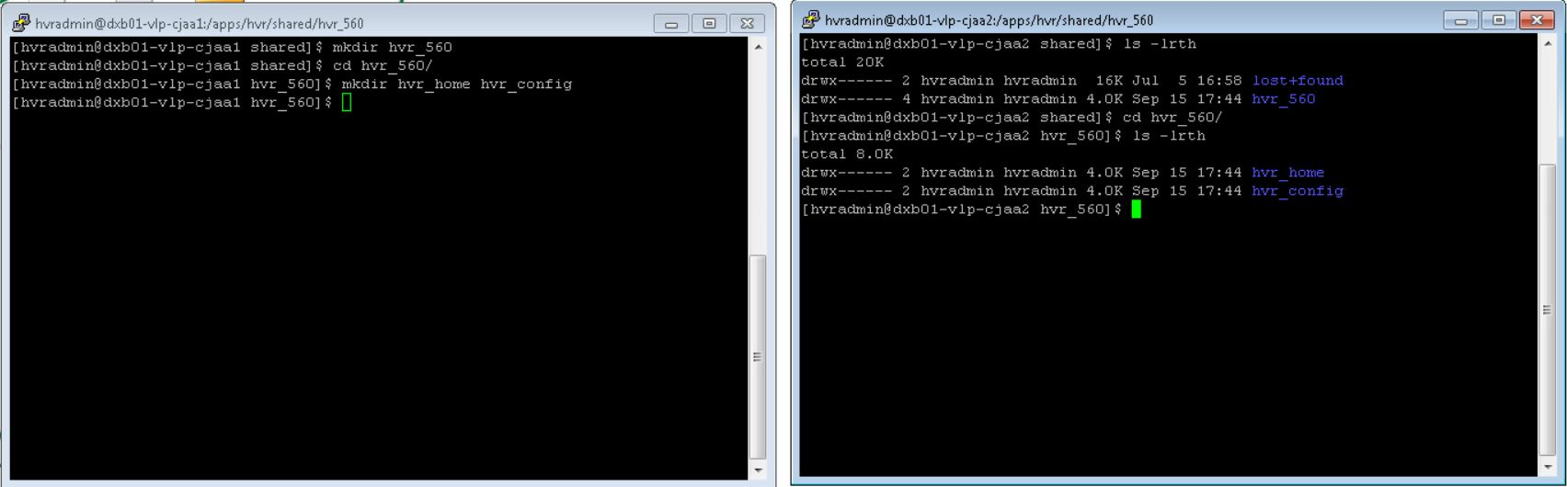

**STEP 2:**

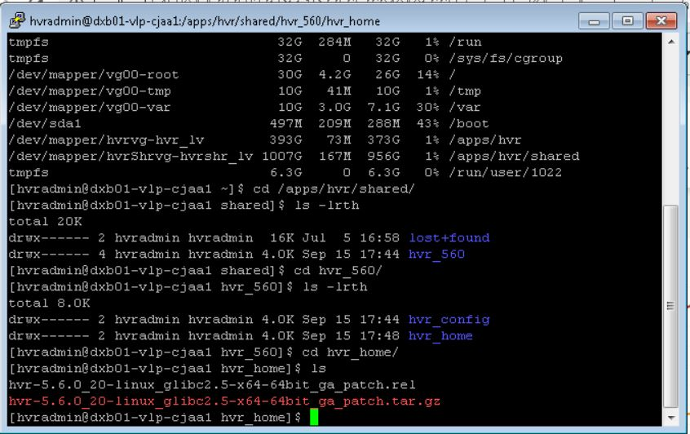

**STEP 3:**



**STEP 4:**



**STEP 5:**

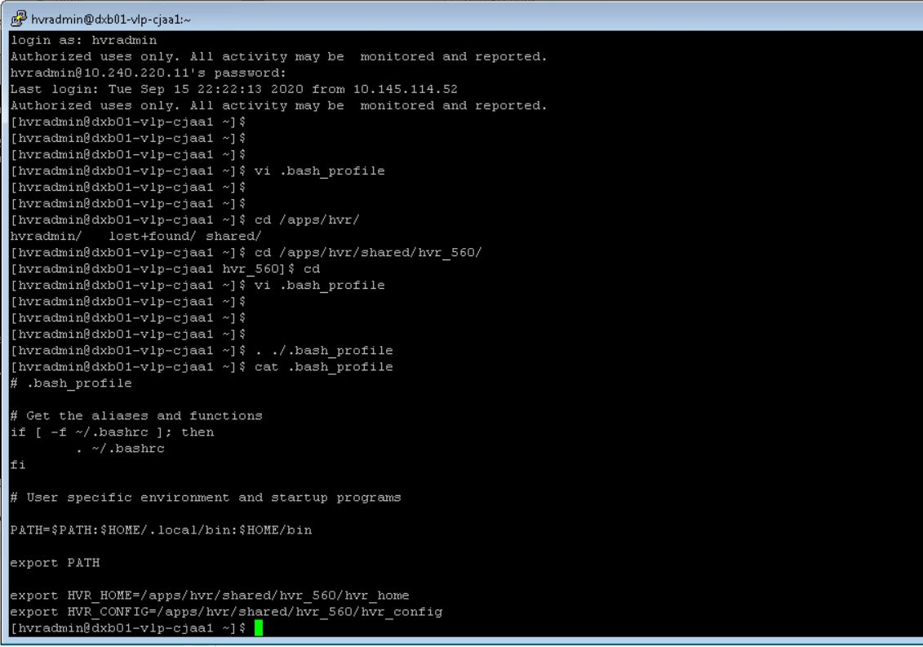

**STEP 6:**

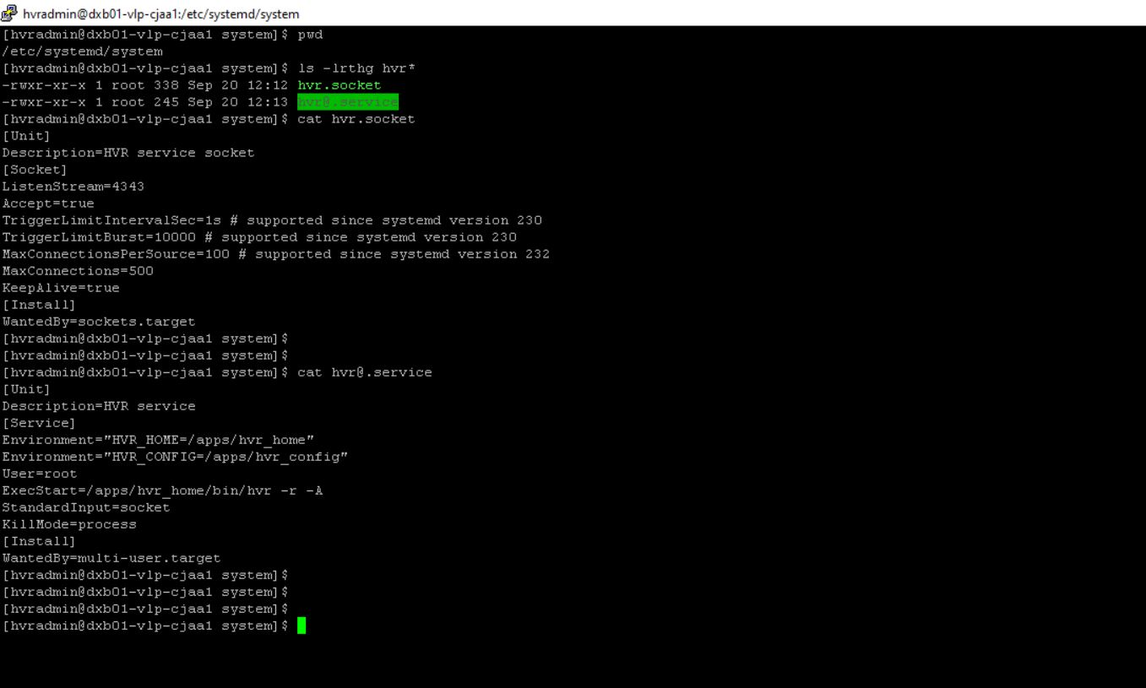

**STEP 7:**

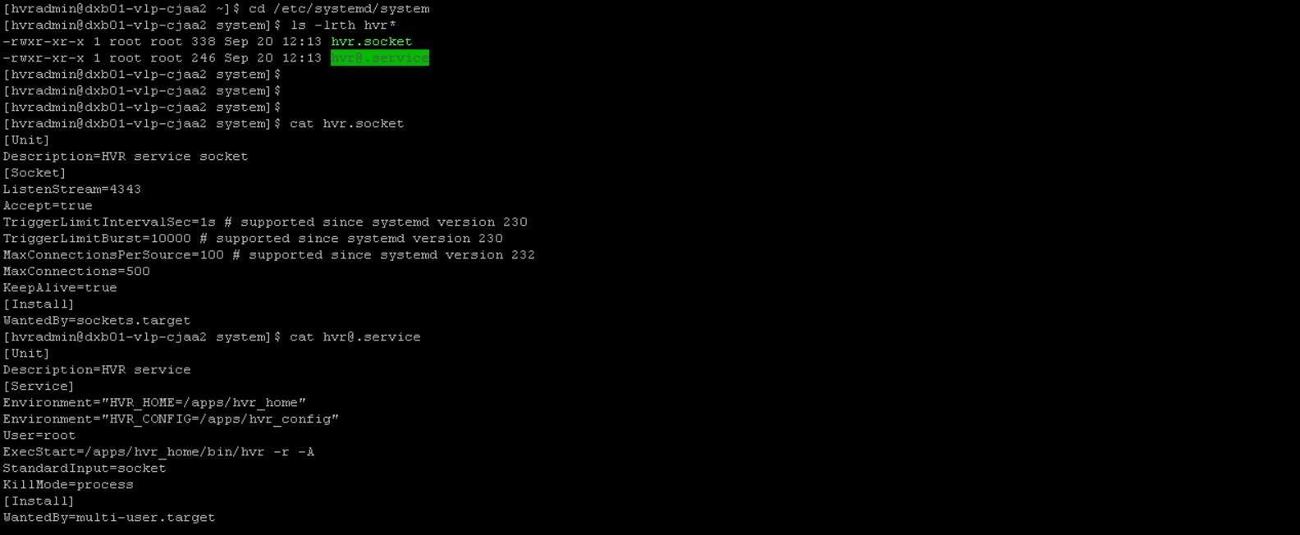

**STEP 8:**

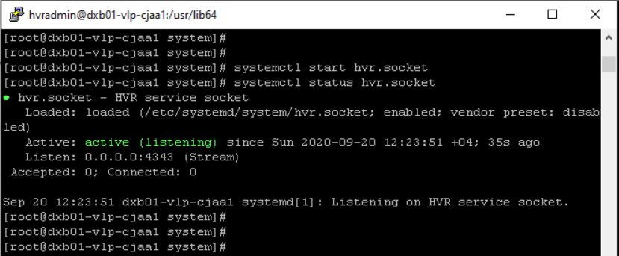

**STEP 9:**

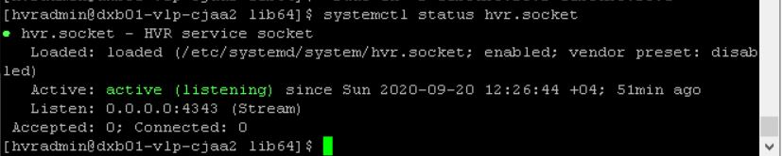

**STEP 10:**

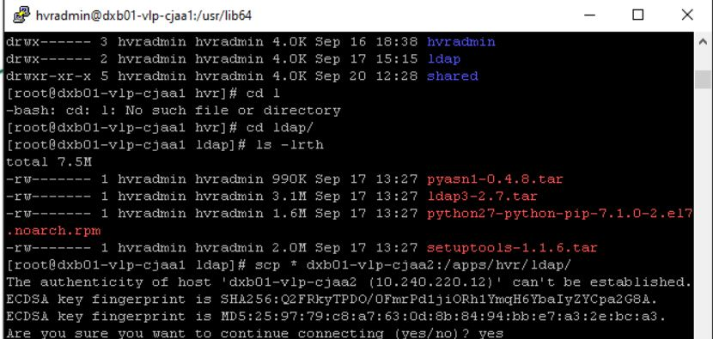

**STEP 11:**

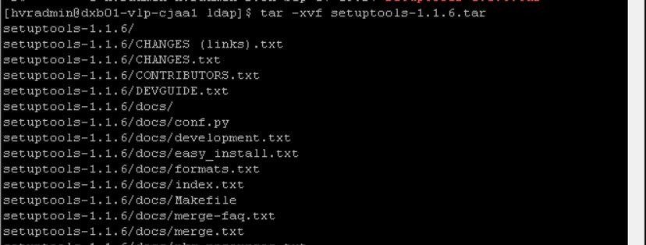

**STEP 12:**

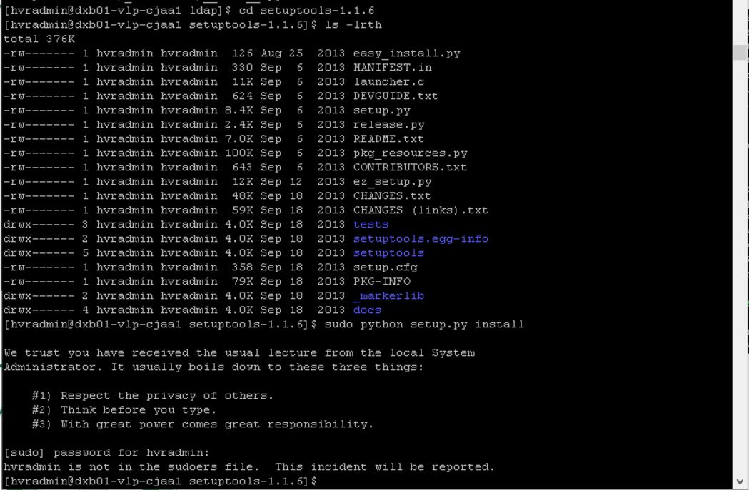

**STEP 13:**

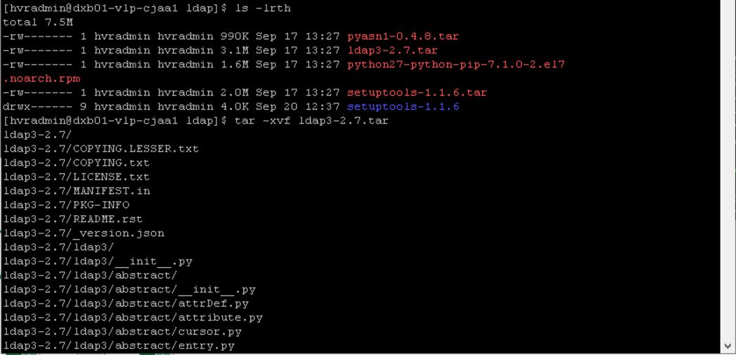

**STEP 14:**

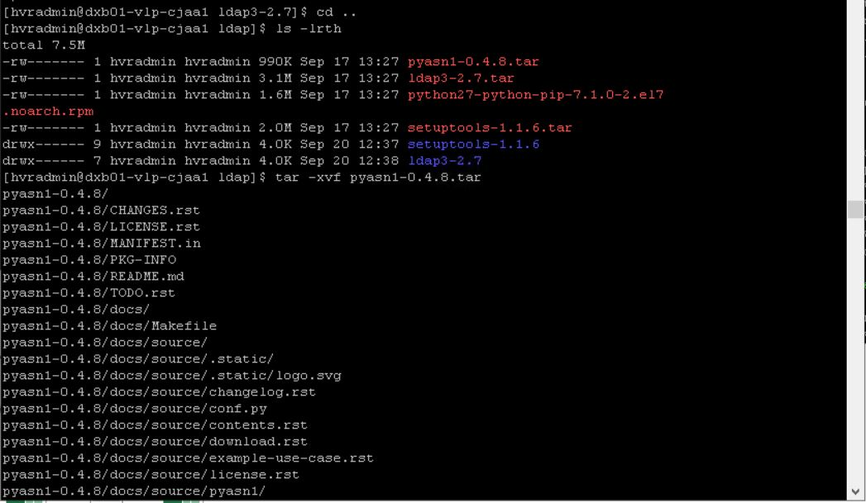

**STEP 15:**

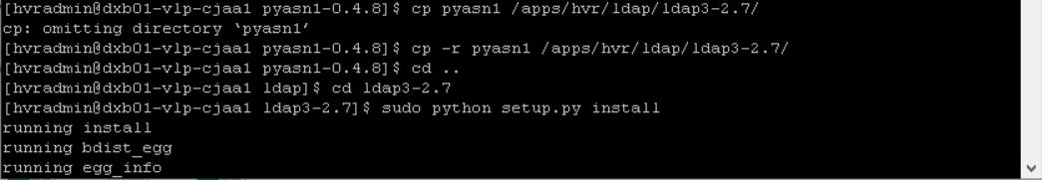

**STEP 16:**

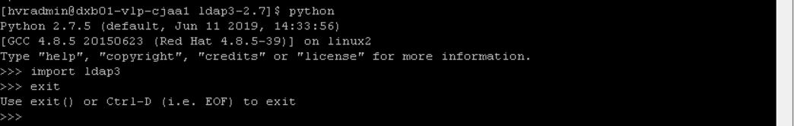

**STEP 17:**

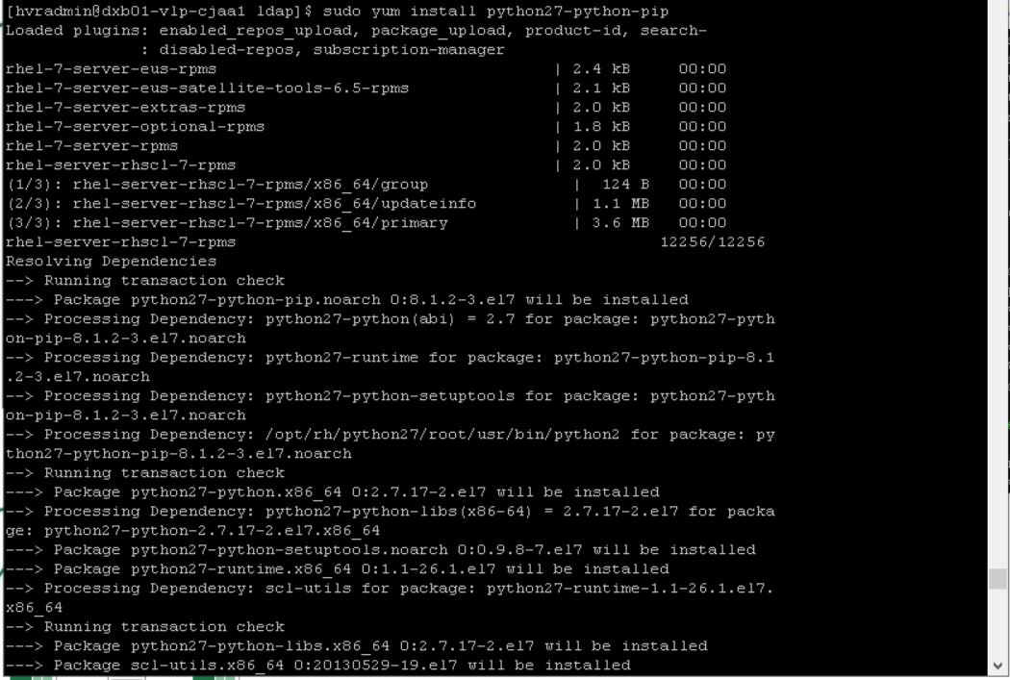

**STEP 18:**

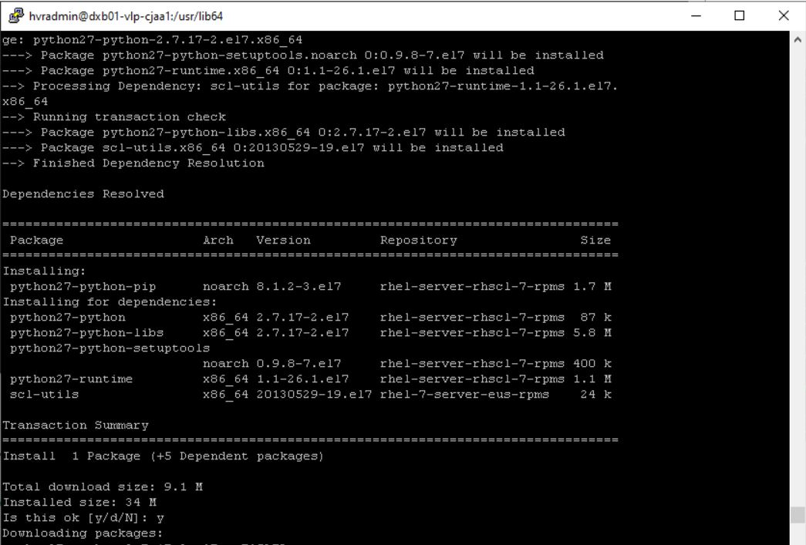

**STEP 19:**

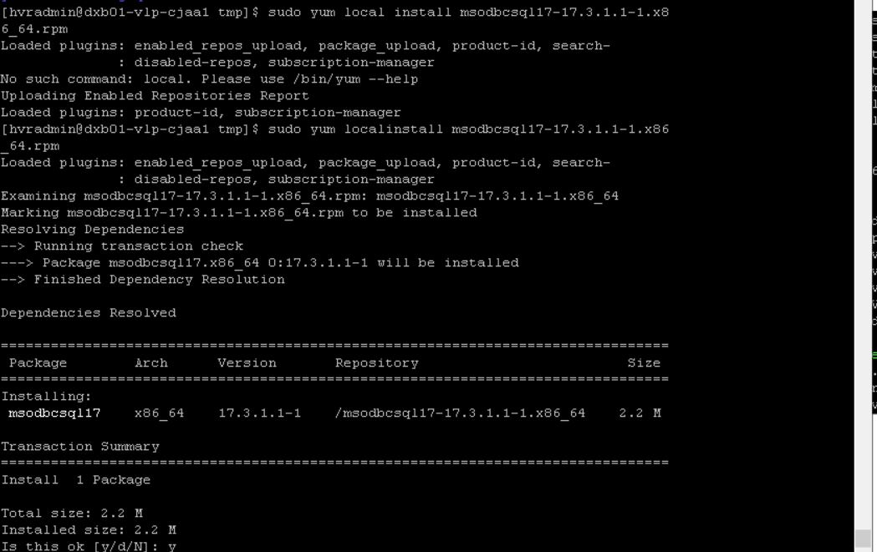

**STEP 20:**



**STEP 21:**

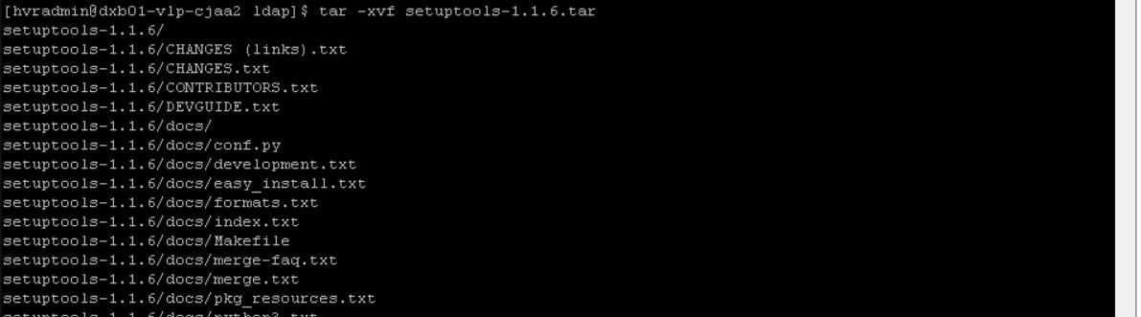

**STEP 22:**

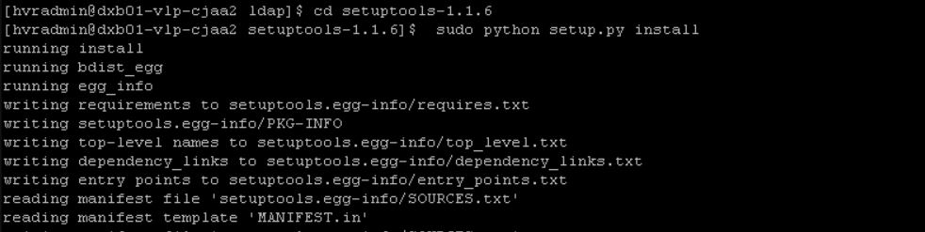

**STEP 23:**

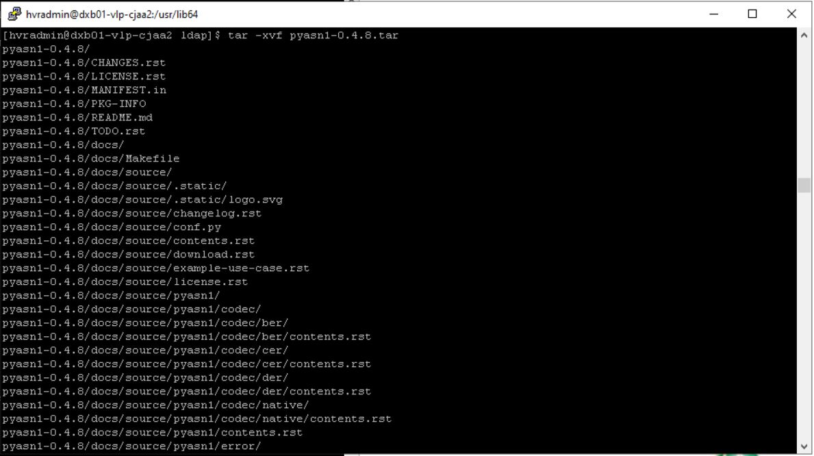

**STEP 24:**

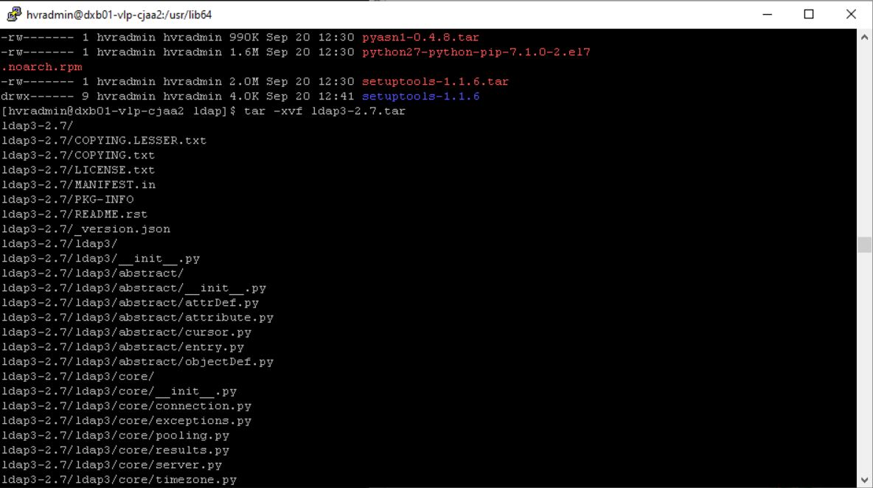

**STEP 25:**

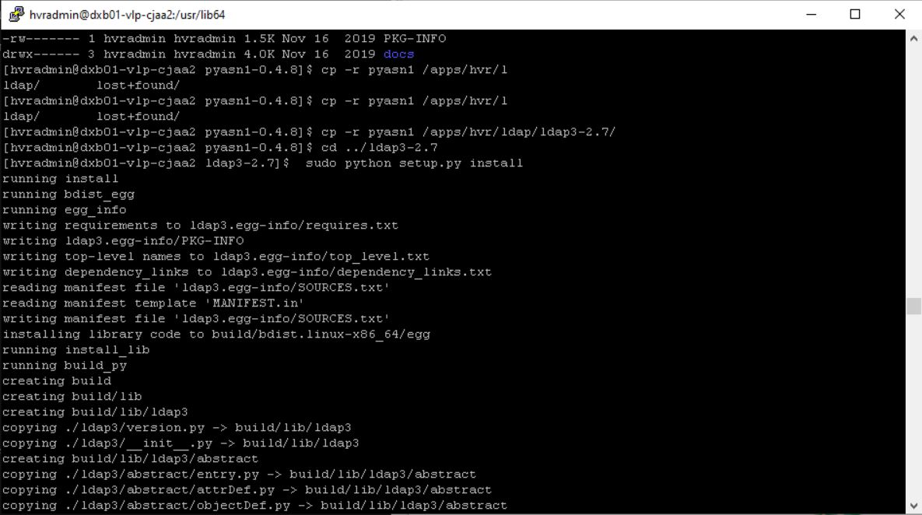

**STEP 26:**

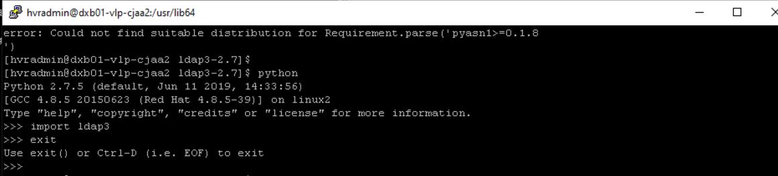

**STEP 27:**

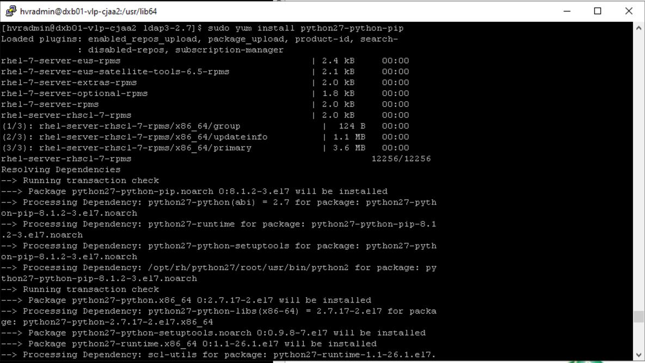

**STEP 28:**

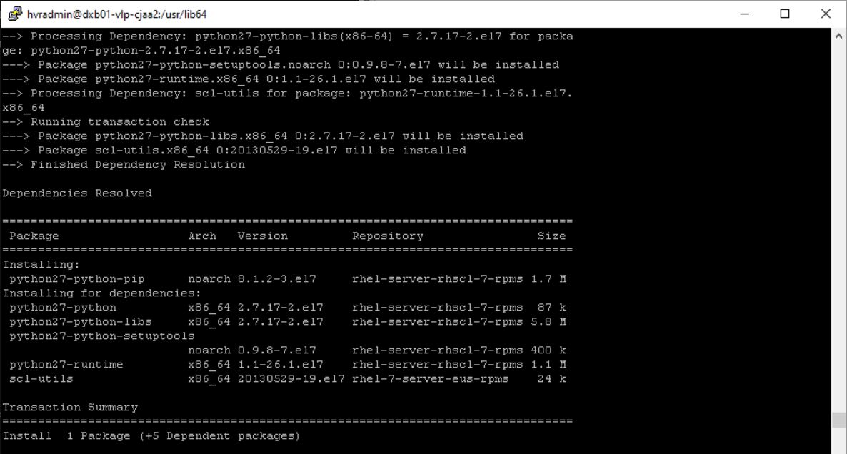

**STEP 29:**

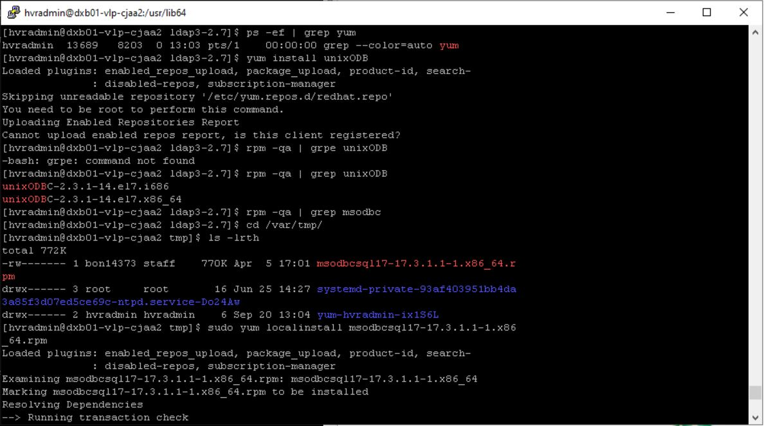

**LDAP CONFIGURATION**

**https://centos.pkgs.org/7/centos-sclo-rh-x86_64/python27-python-pip-7.1.0-2.el7.noarch.rpm.html**

**https://files.pythonhosted.org/packages/a4/db/fffec68299e6d7bad3d504147f9094830b704527a7fc098b721d38cc7fa7/pyasn1-0.4.8.tar.gz**

**Install python2-pyasn1**

**1. Download https://files.pythonhosted.org/packages/f6/7c/f43c90d21e676d2738c81674a21fad63a8d5f71d6e39cd35966214b7ce6c/setuptools-1.1.6.tar.gz**

**2. Copy the gz file to HVR hub and unzip it in a temporary folder**

**3. cd setuptools-1.1.6**

**4. sudo python setup.py install**

**5. Download https://files.pythonhosted.org/packages/c2/49/3bf179229a92ae87ff2dca1609c2ad599c497938f90fd5d66d02aa8e977e/ldap3-2.7.tar.gz**

**6. Copy the gz file to HVR hub and unzip it in a temporary folder**

**7. cd ldap3-2.7**

**8. sudo python setup.py install**

**Download https://files.pythonhosted.org/packages/a4/db/fffec68299e6d7bad3d504147f9094830b704527a7fc098b721d38cc7fa7/pyasn1-0.4.8.tar.gz**

**Copy the gz file to HVR hub and unzip it in a temporary folder**

**cd pyasn1-0.4.8**

**sudo python setup.py install**

**9. Test if ldap3 is properly installed: Type "python" and then "import ldap3". You should see this output (no errors):**

**$ python**

**Python 2.7.5 (default, Oct 11 2015, 17:47:16)**

**[GCC 4.8.3 20140911 (Red Hat 4.8.3-9)] on linux2**

**Type "help", "copyright", "credits" or "license" for more information.**

**>>> import ldap3**

**10. Cleanup. Delete the gz files and folders from the temporary folder**

**STEP 30:**



**STEP 31:**

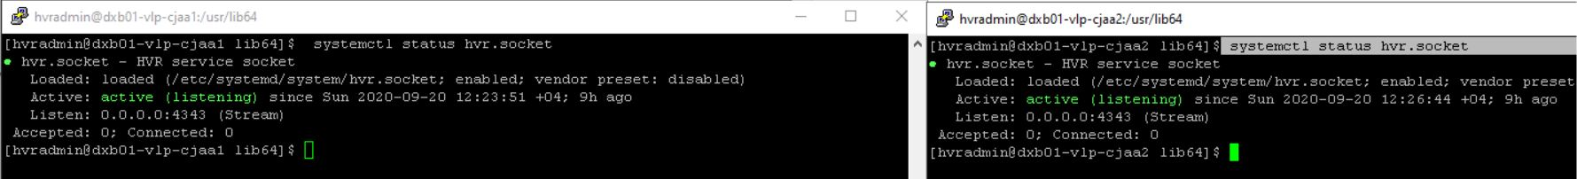

**STEP 33:**

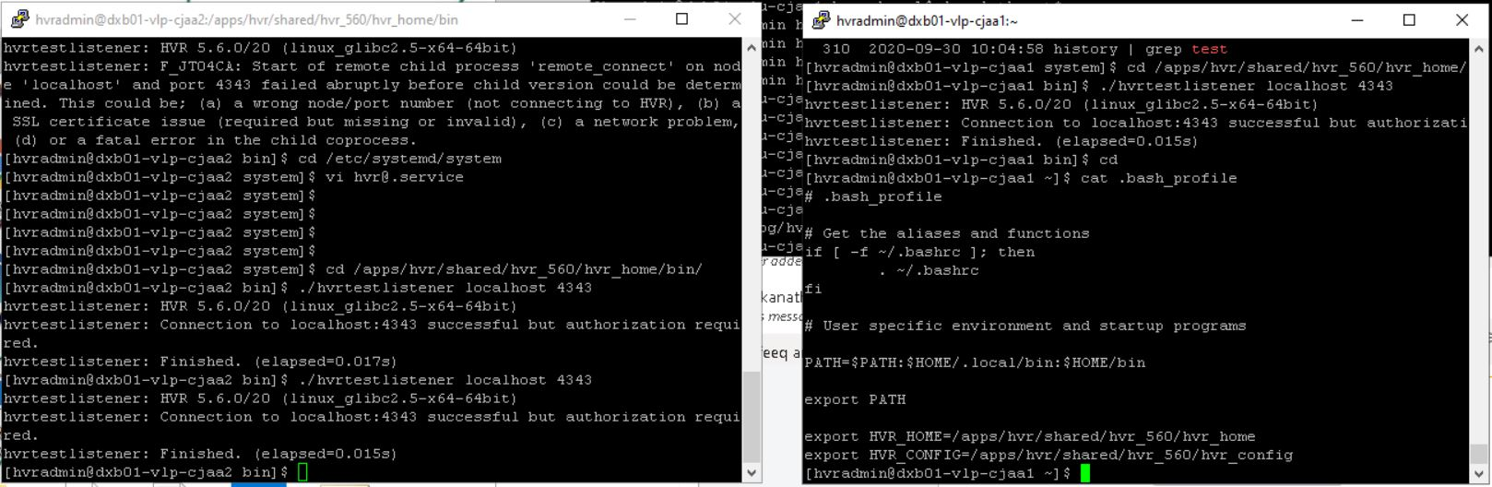

# **HVR AGENT INSTALLATION ON SOURCE SERVERS - UNIX**

## **COREBANKING**

**STEP 1:**

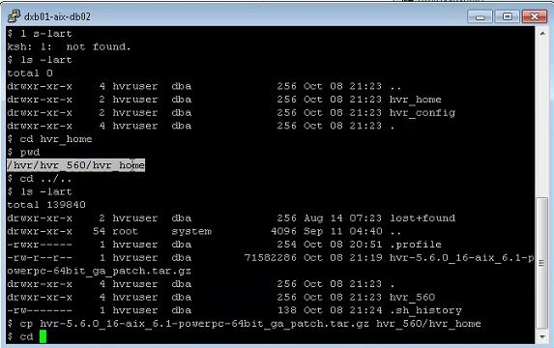

**STEP 2:**

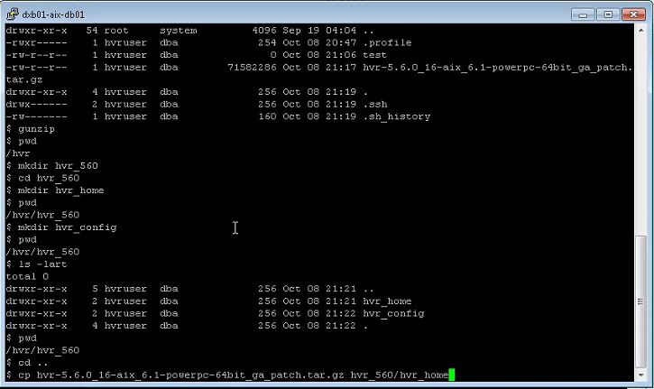

**STEP 3:**

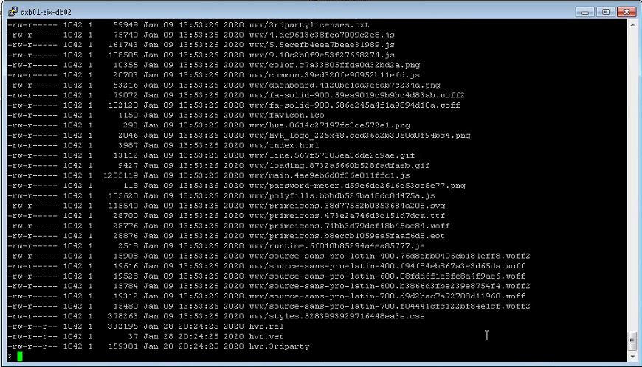

**STEP 4:**

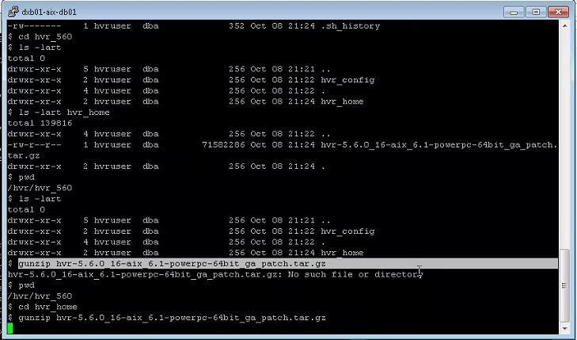

**STEP 5:**

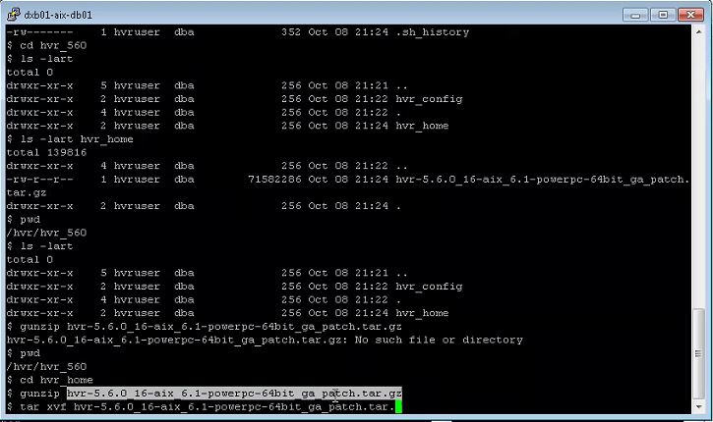

**STEP 6:**

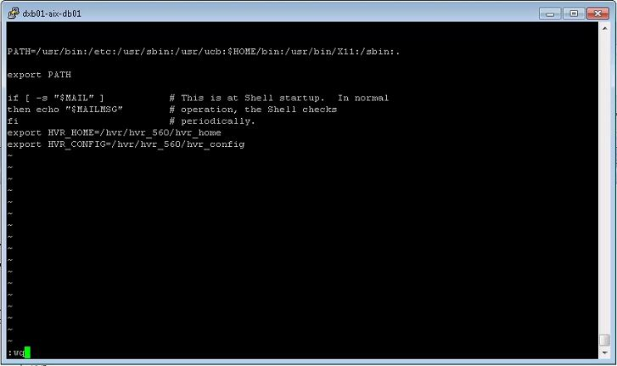

**STEP 7:**

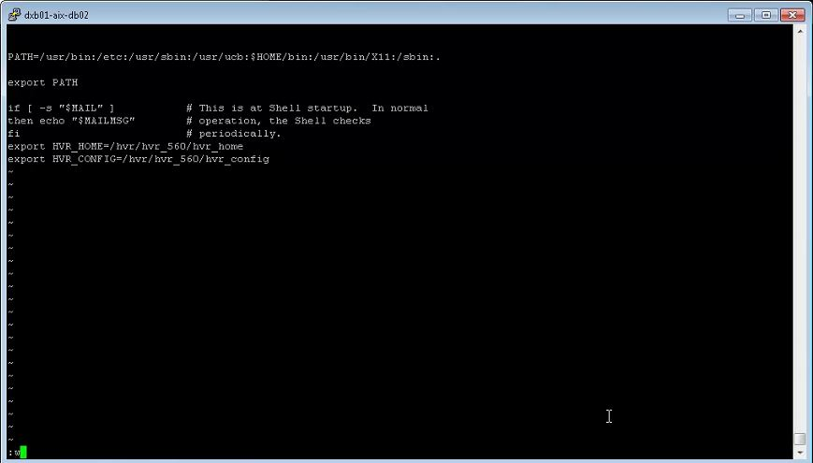

**STEP 8:**

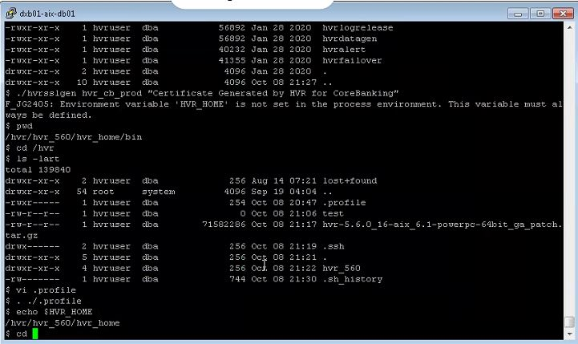

**STEP 9:**

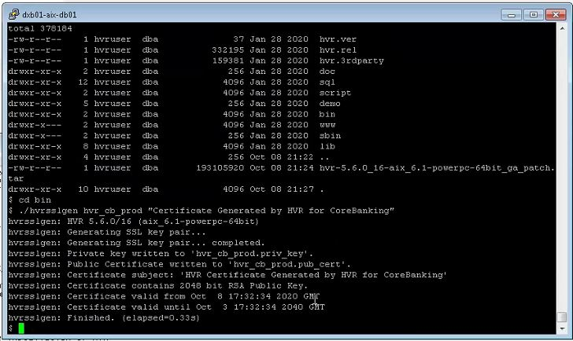

**STEP 10:**

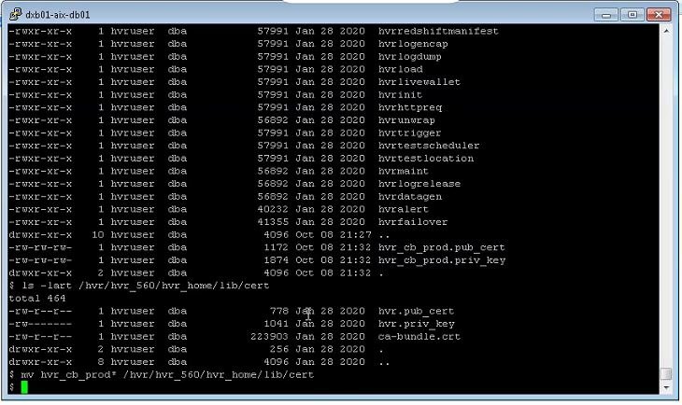

**STEP 11:**

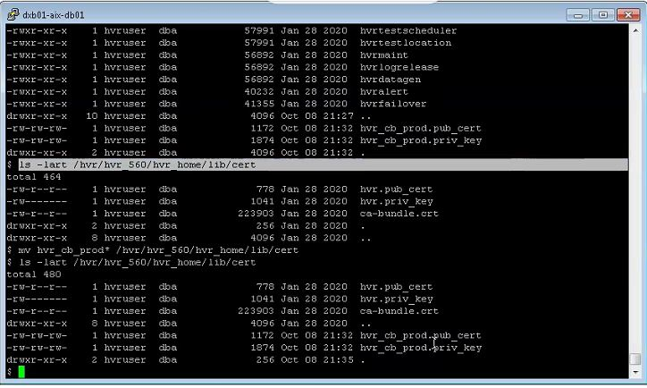

**STEP 12:**

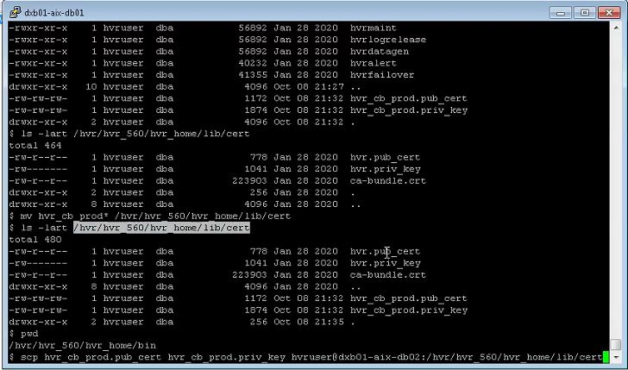

**STEP 13:**

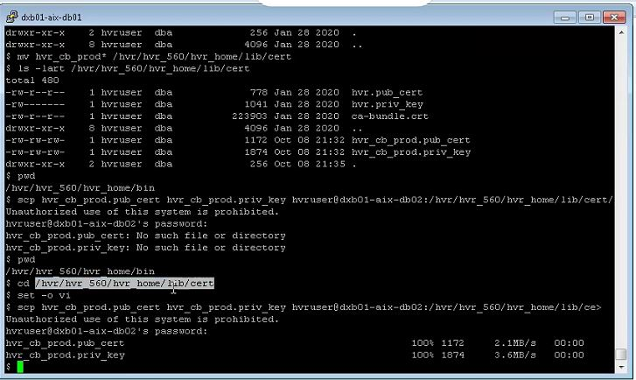

**STEP 14:**

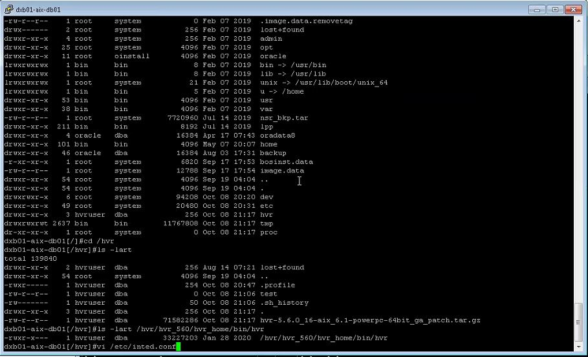

**STEP 15:**

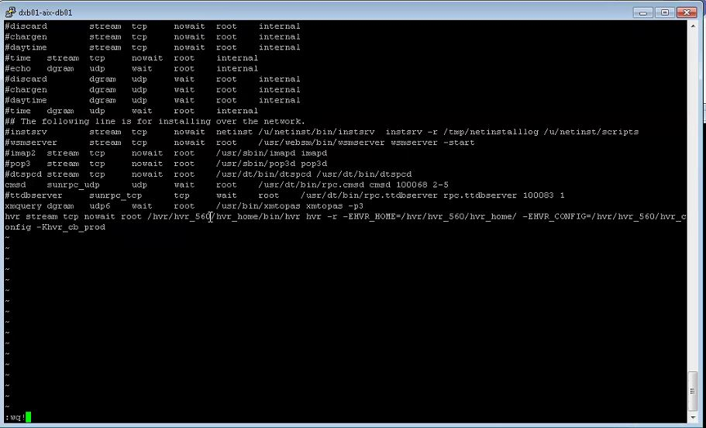

**STEP 16:**

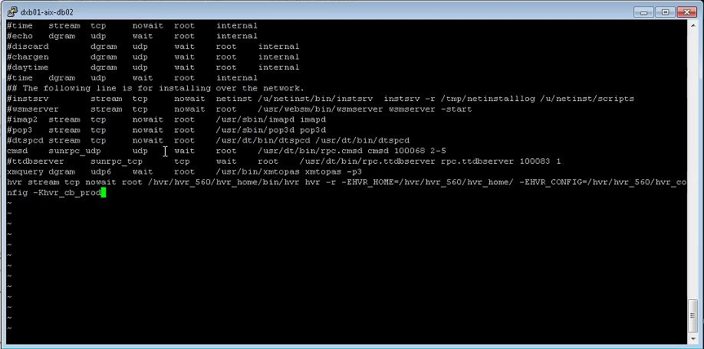

**STEP 17:**

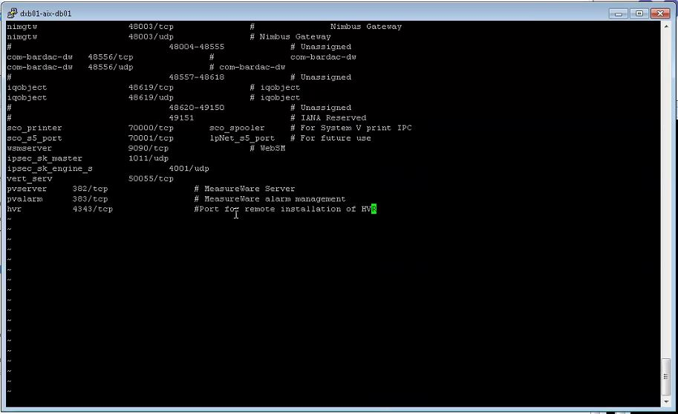

**STEP 18:**

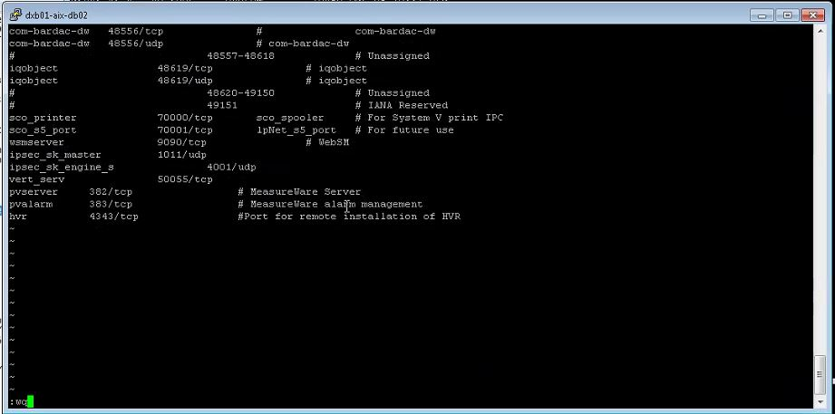

**STEP 19:**

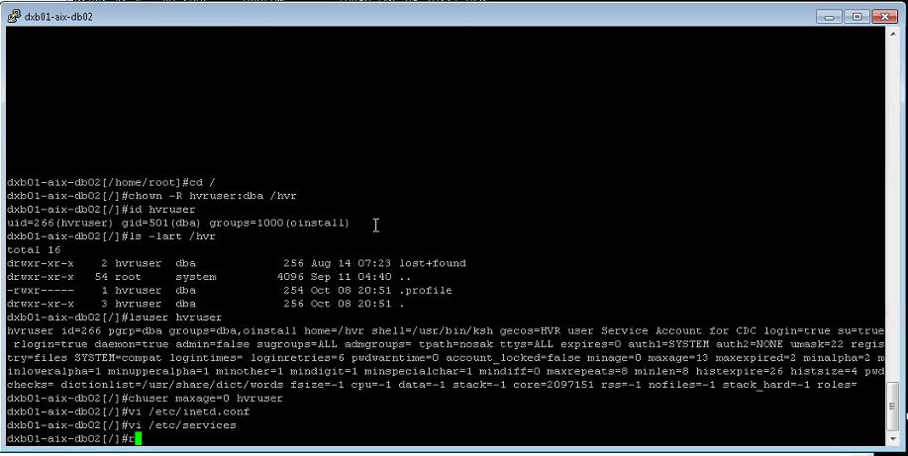

**STEP 20 :**

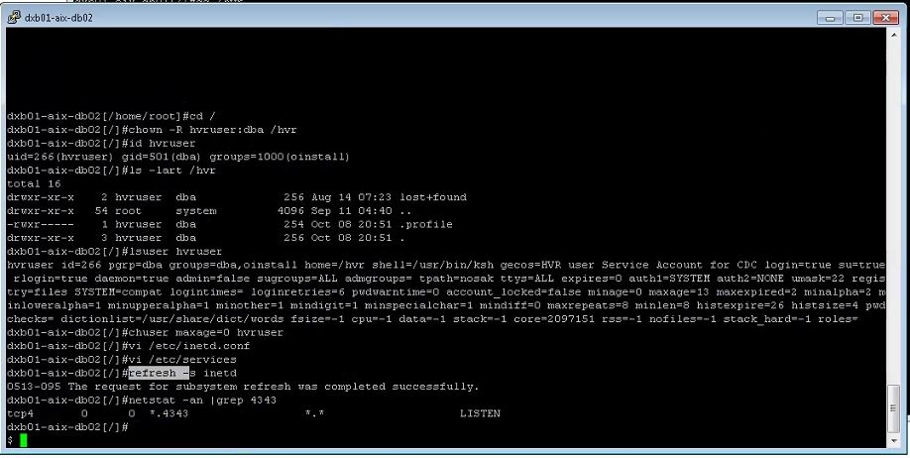

**STEP 21:**

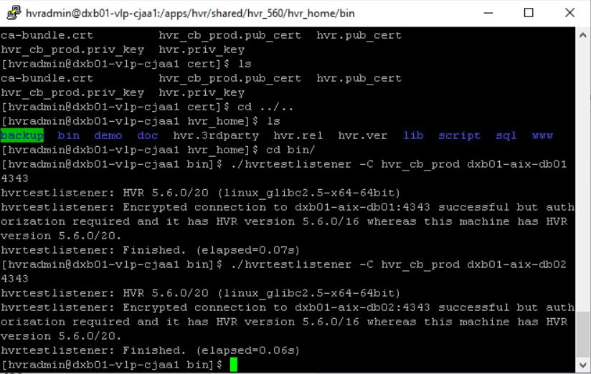

**STEP 22:**

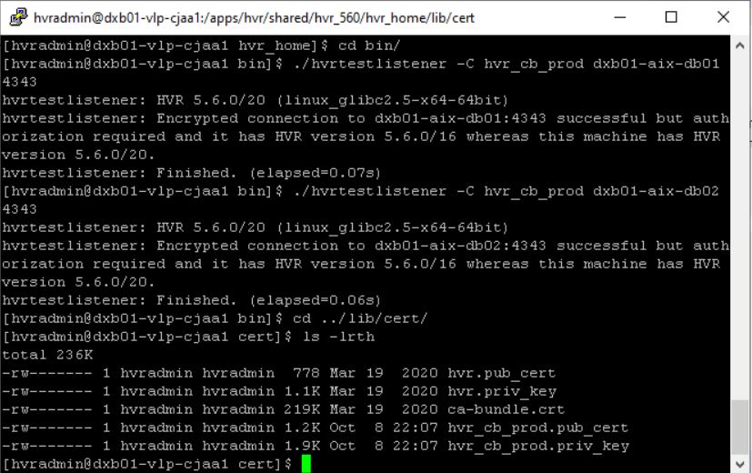

## **COREBANKING DR**

**STEP 1:**

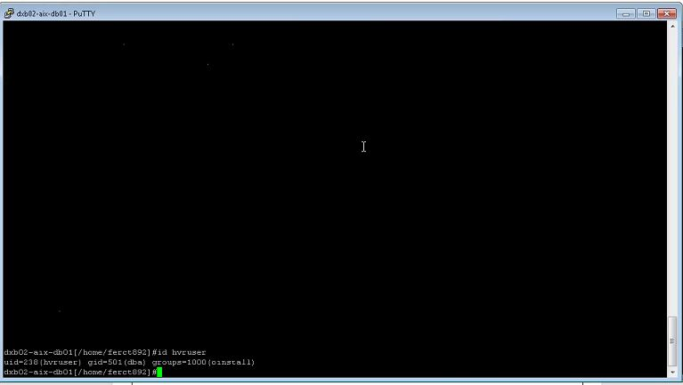

**STEP 2:**

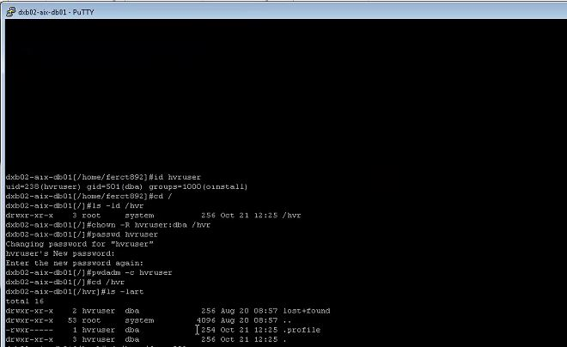

**STEP 3:**

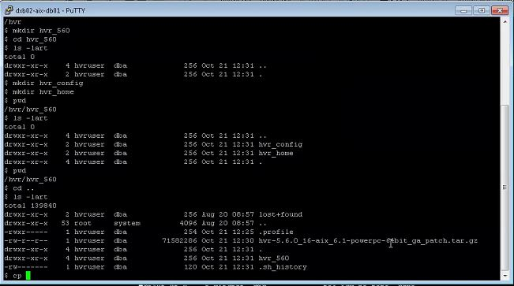

**STEP 4:**

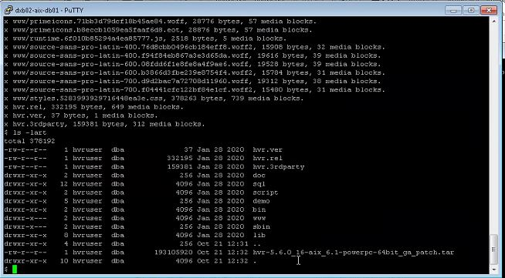

**STEP 5:**

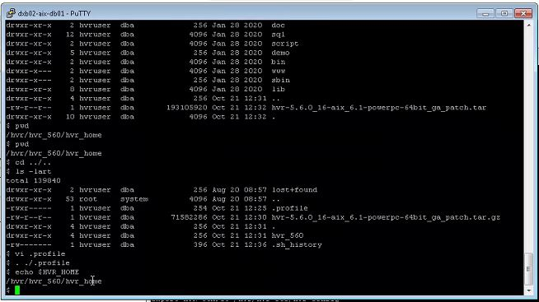

**STEP 6:**

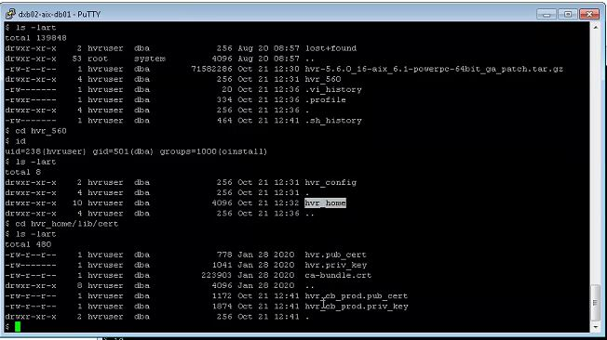

**STEP 7:**

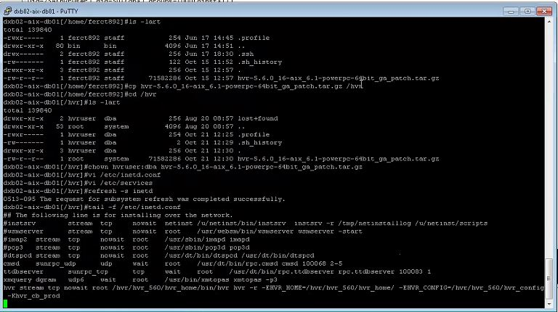

**STEP 8:**

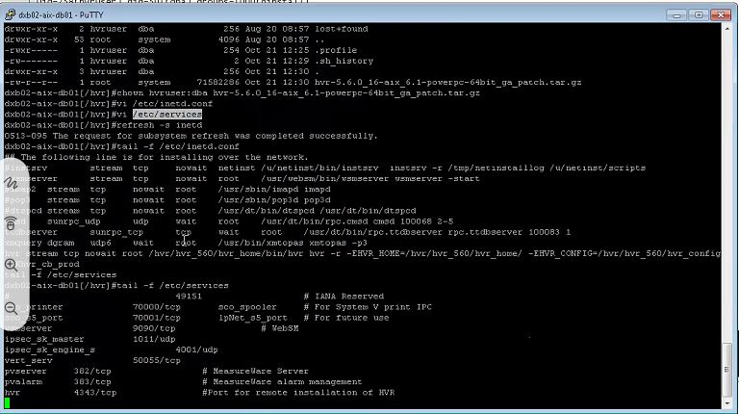

**STEP 9: TEST**

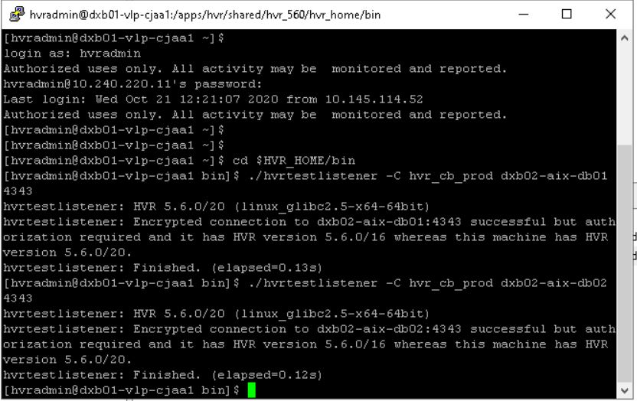

**STEP 10:**

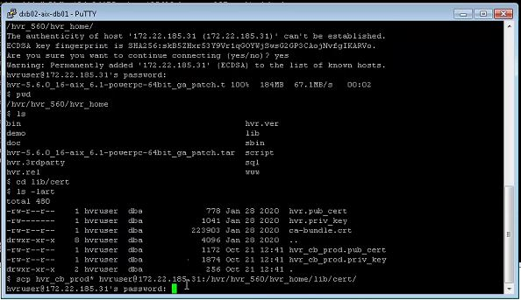

**STEP 11:**

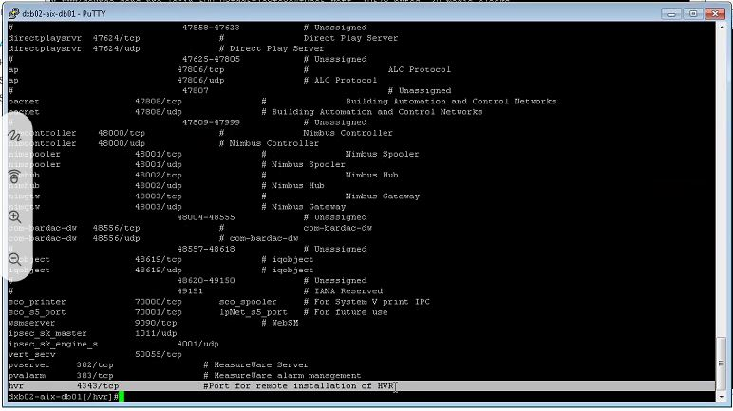

**STEP 12:**

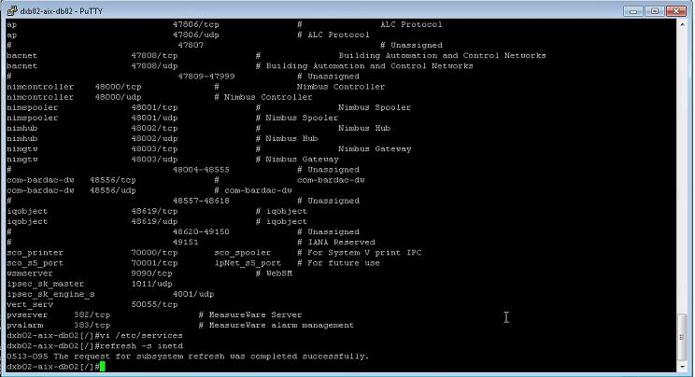

## **FINNONE**

**STEP 1:**



**STEP 2:**

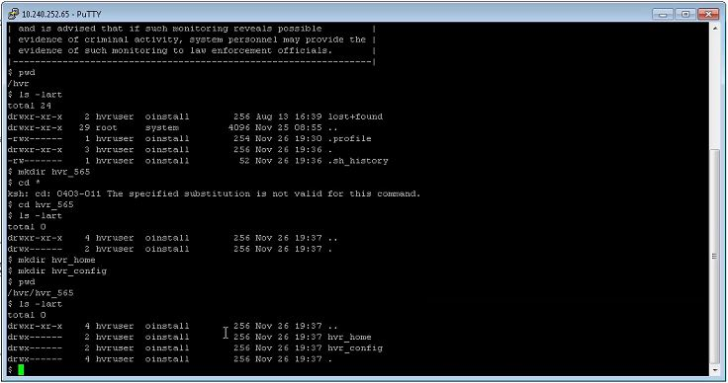

**STEP 3:**

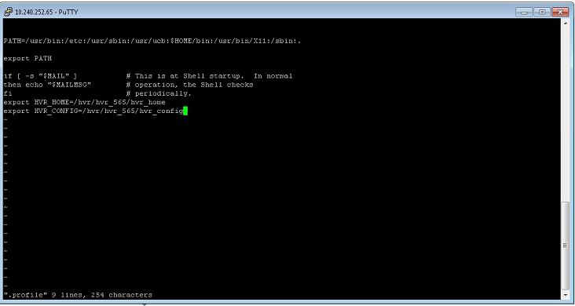

**STEP 4:**

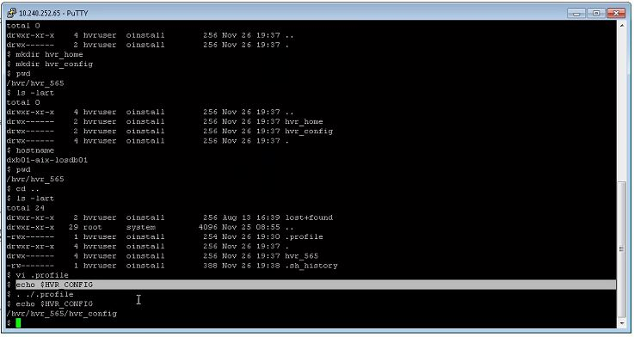

**STEP 5:**

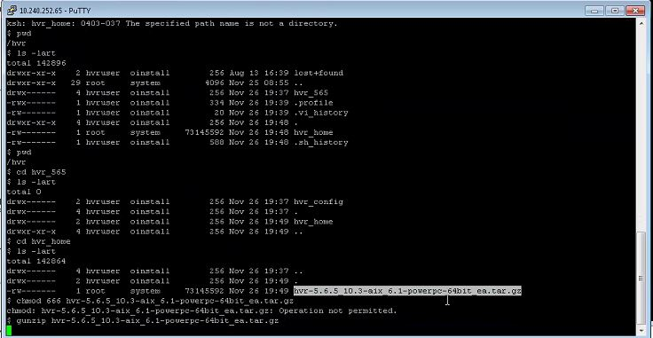

**STEP 6:**

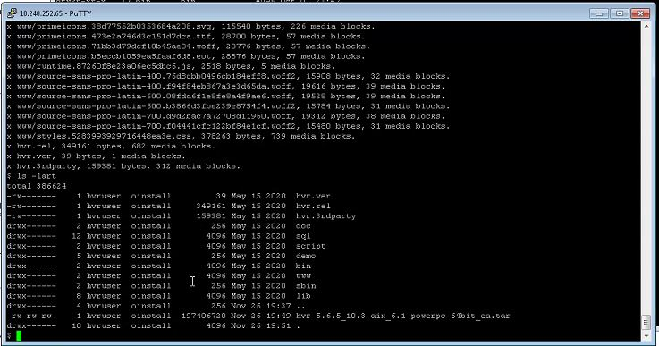

**STEP 7:**

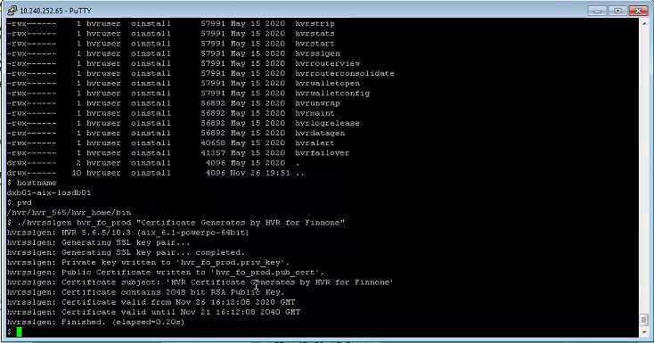

**STEP 8:**

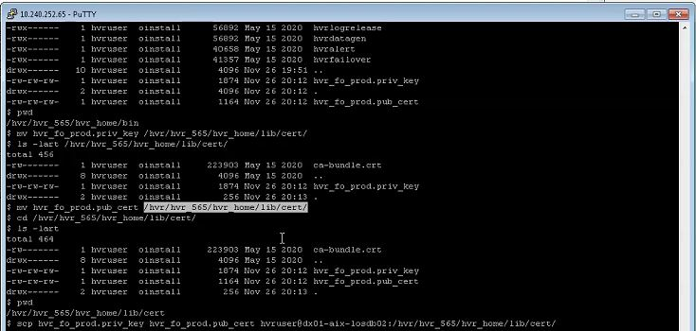

**STEP 9:**

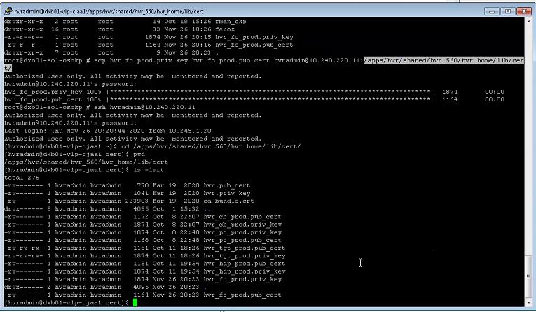

**STEP 10:**

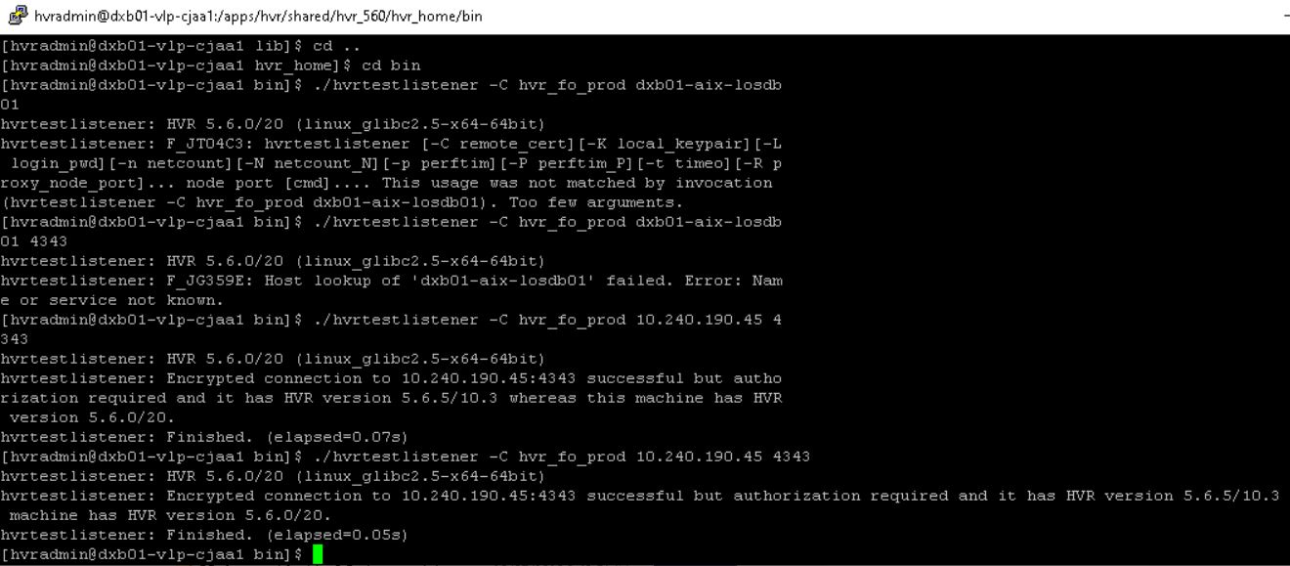

**STEP 11:**

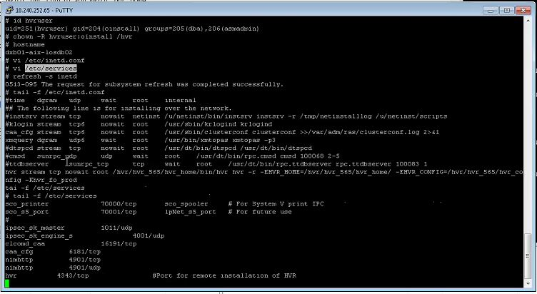

**STEP 12:**

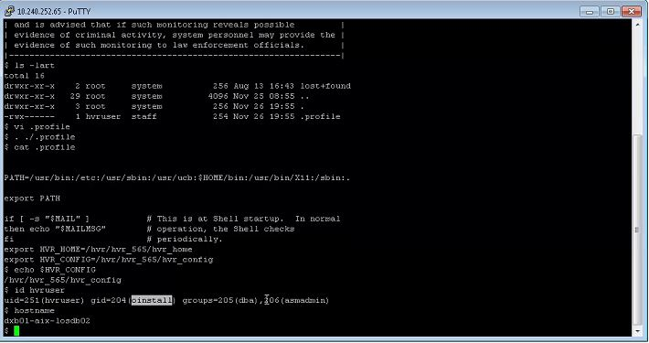

**STEP 13:**

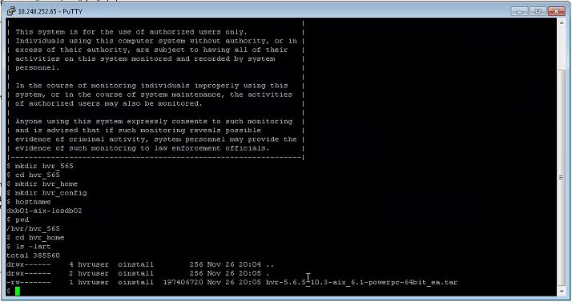

**STEP 14:**

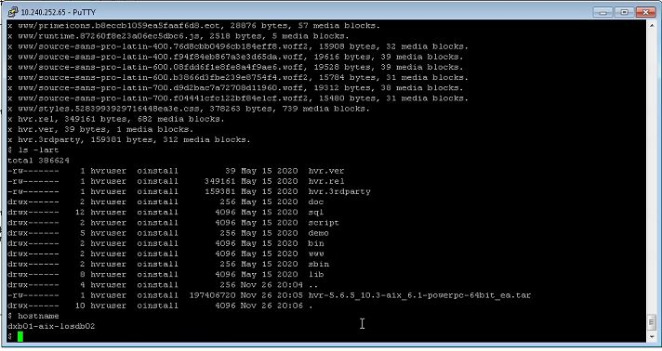

**STEP 15:**

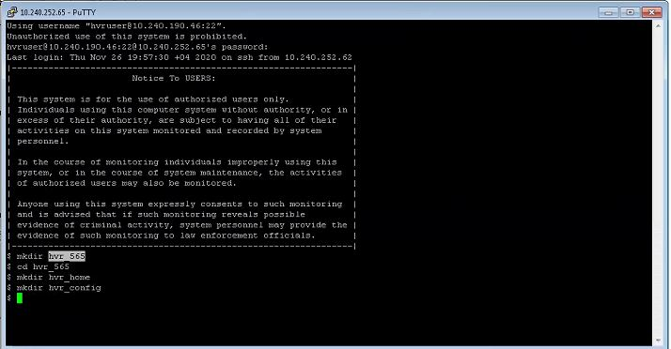

## **FINONE DR**

**STEP 1:**



**STEP 2:**



**STEP 3:**



**STEP 4:**



**STEP 5:**



**STEP 6:**



**STEP 7:**



**STEP 8:**



**STEP 9:**



**STEP 10:**



**STEP 11:**



**STEP 12:**



**STEP 13:**



**STEP 14:**



**STEP 15:**



**STEP 16: TEST**

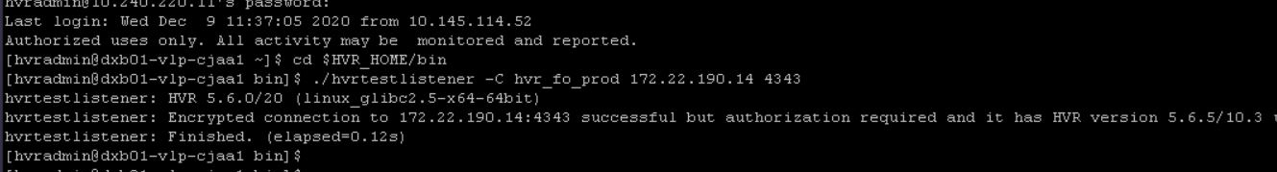

## **POWERCARD**

**STEP 1:**

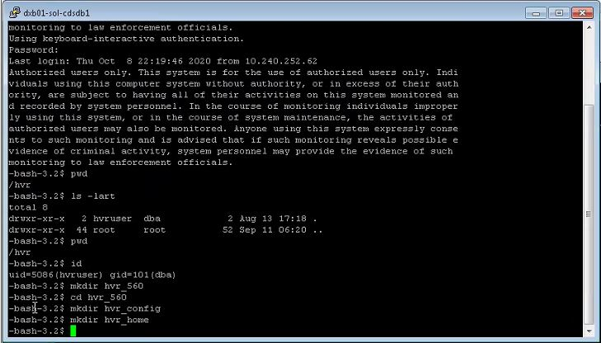

**STEP 2:**

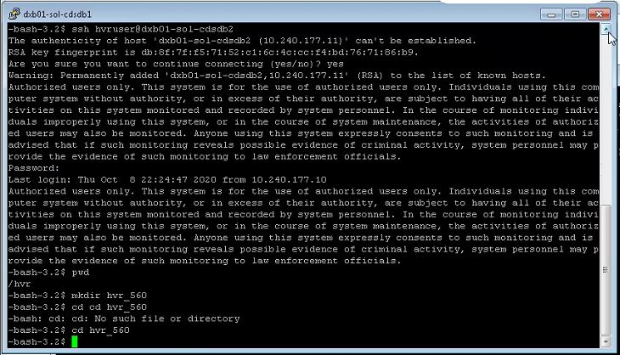

**STEP 3:**

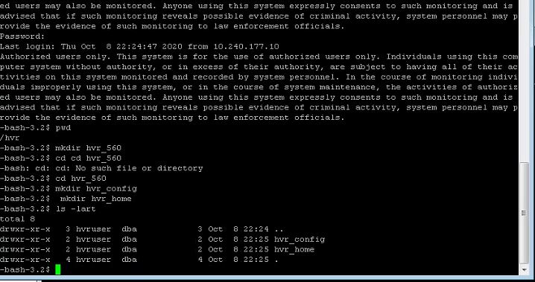

**STEP 4:**

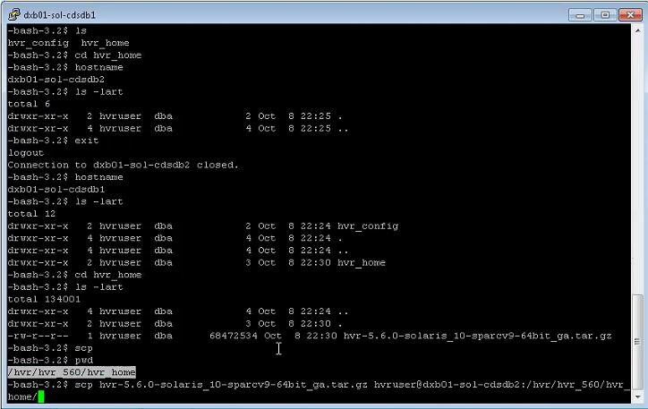

**STEP 5:**

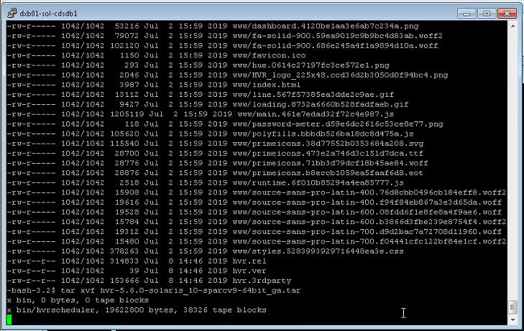

**STEP 6:**

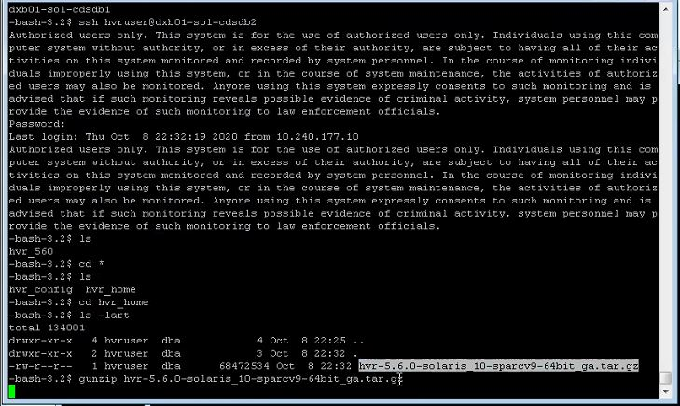

**STEP 7:**

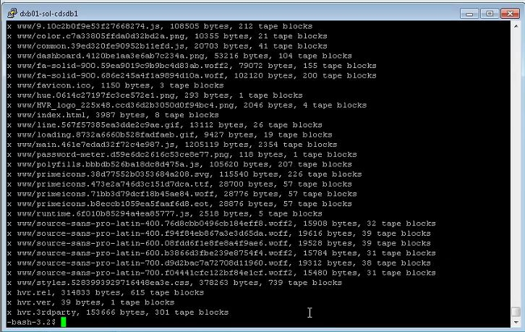

**STEP 8:**

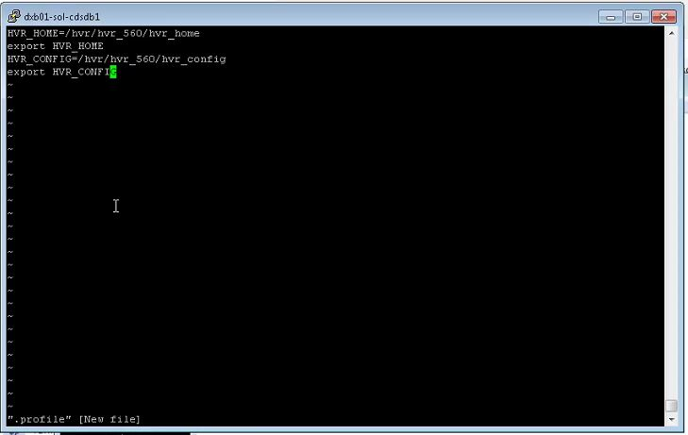

**STEP 9:**

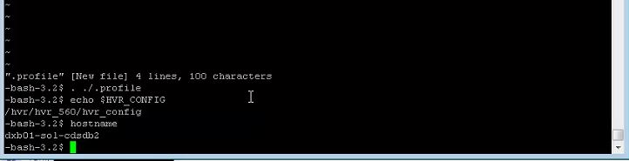

**STEP 10:**

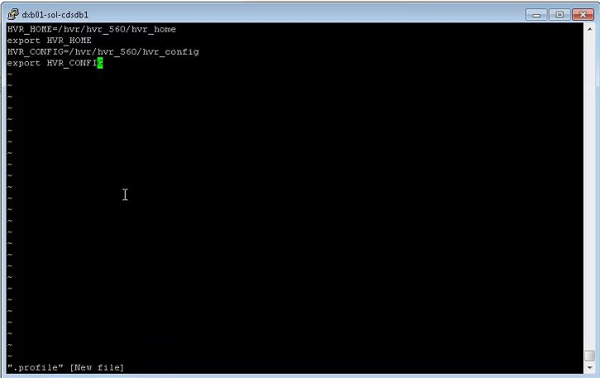

**STEP 11:**

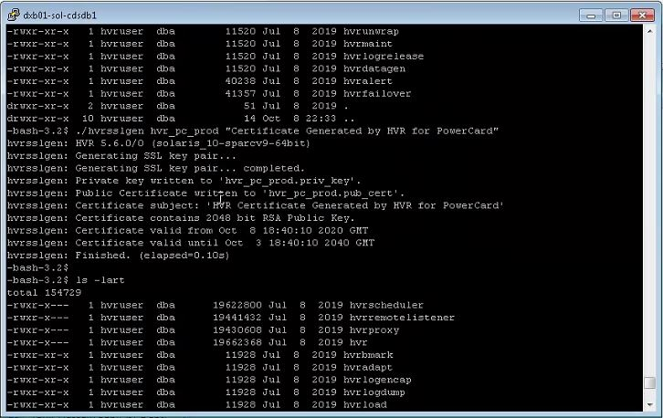

**STEP 12:**

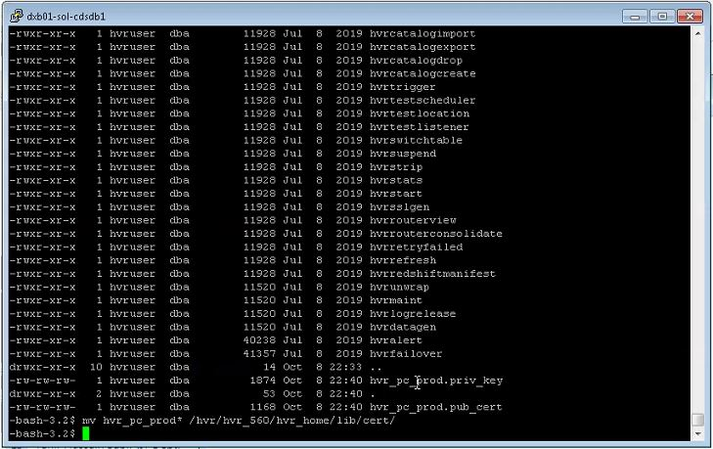

**STEP 13:**

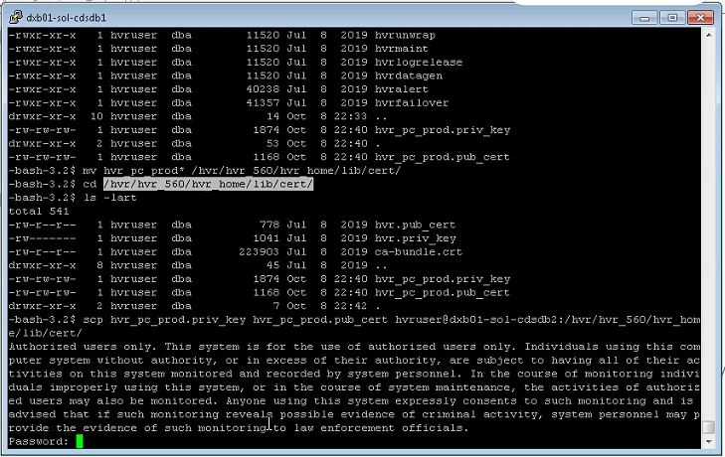

**STEP 14:**

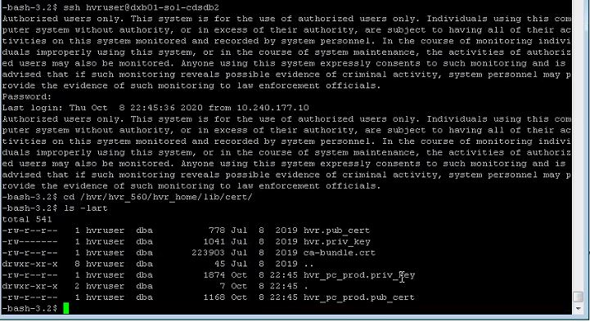

**STEP 15:**

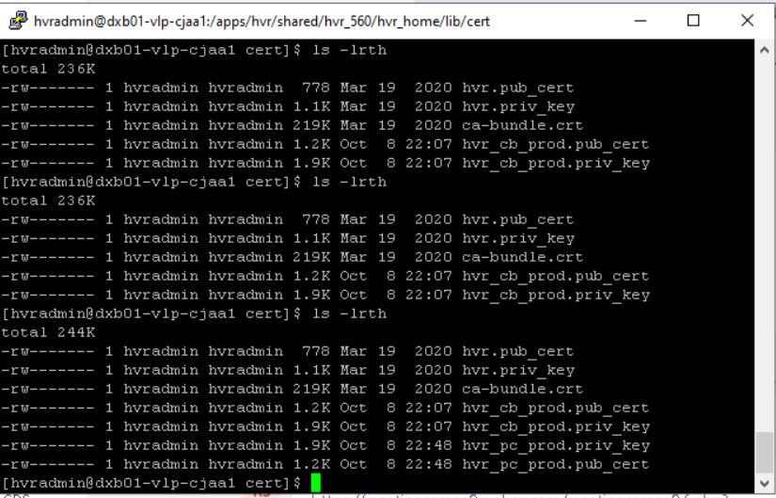

**STEP 16**

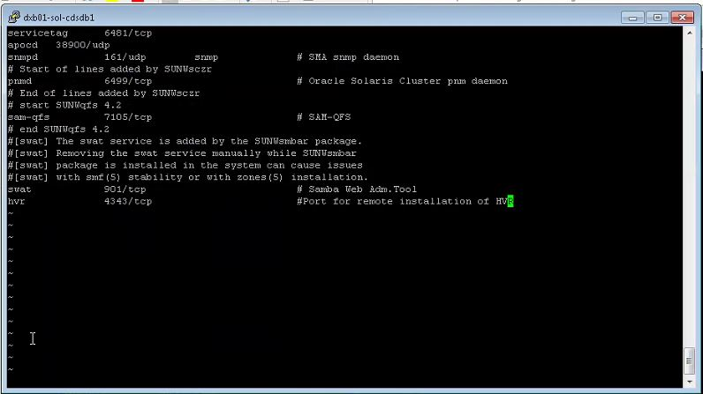

**STEP 17**

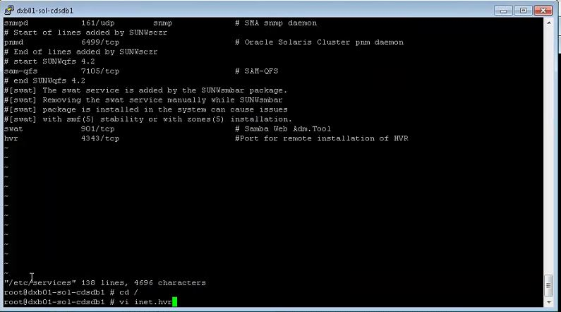

**STEP 18**

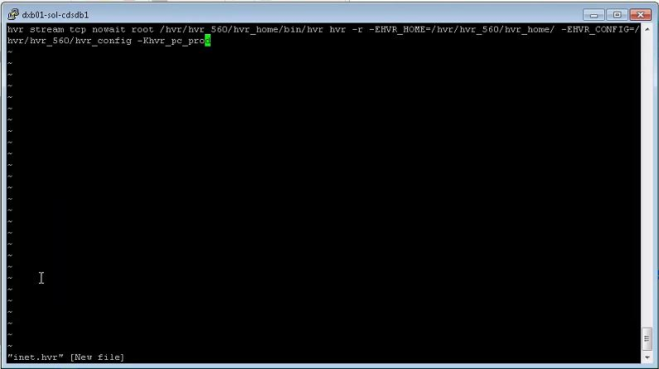

**STEP 19**

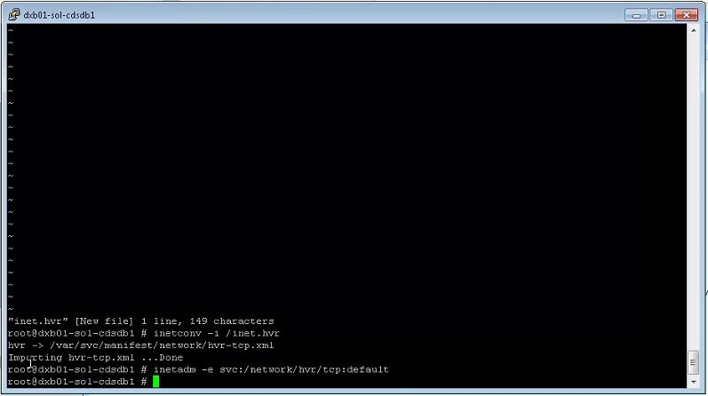

**STEP 20**

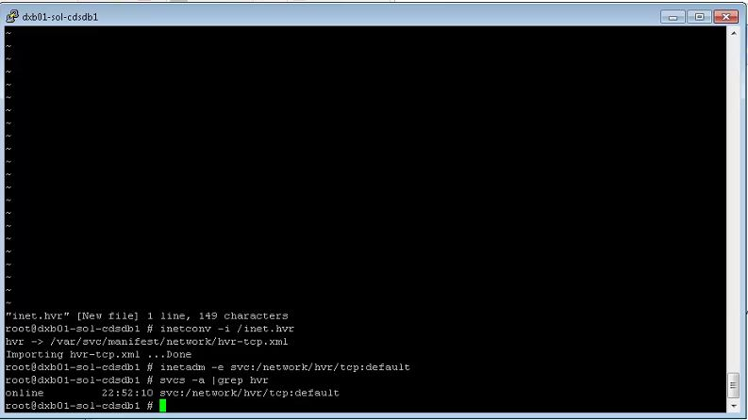

**STEP 21**

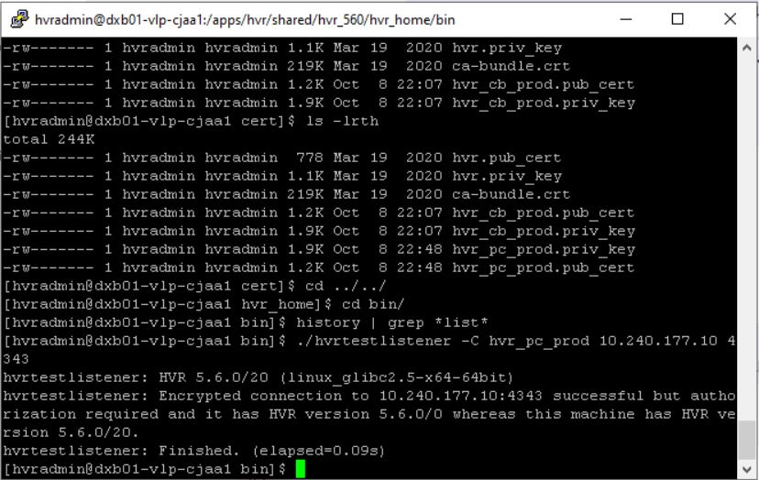

**STEP 22**

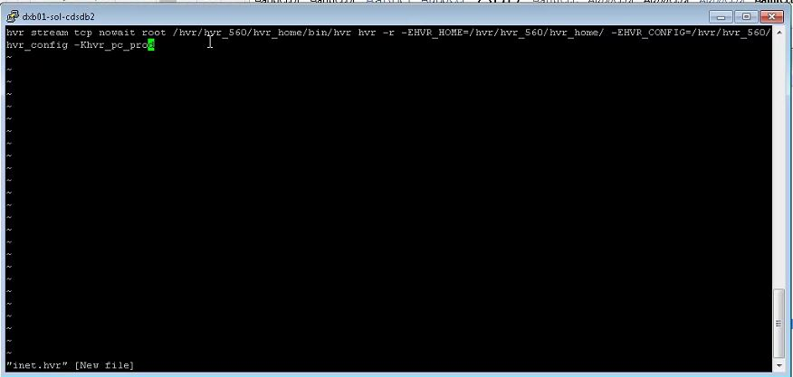

**STEP 23**

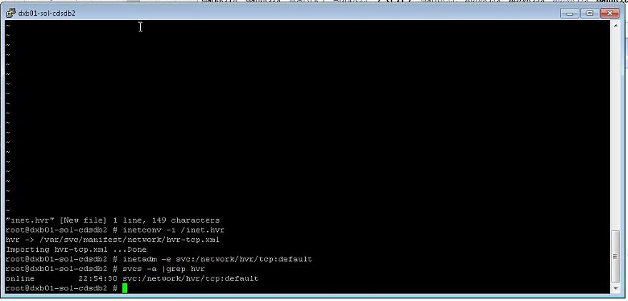

**STEP 24**

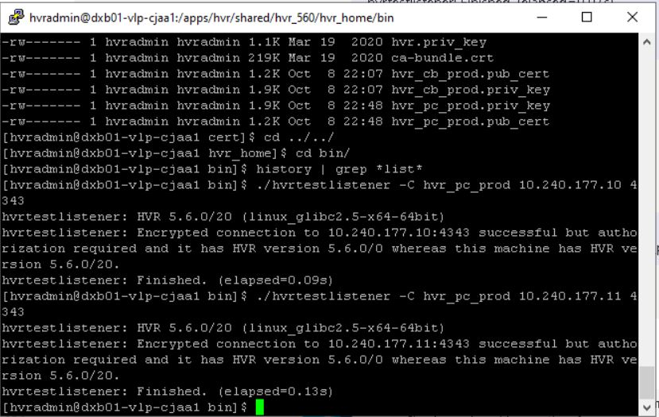

## **POWERCARD DR**

**STEP 1:**

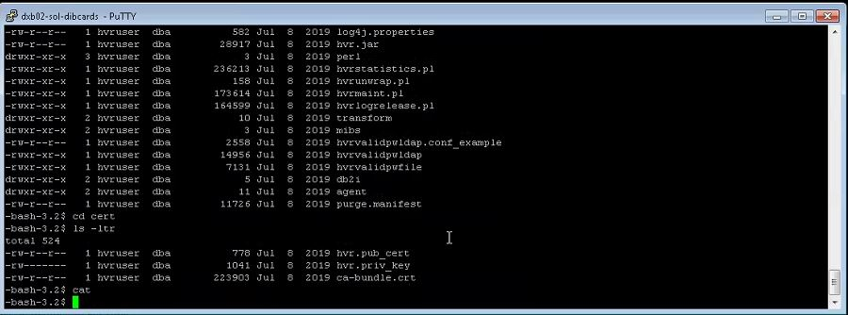

**STEP 2:**

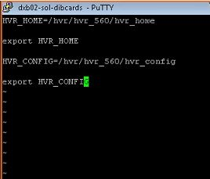

**STEP 3:**

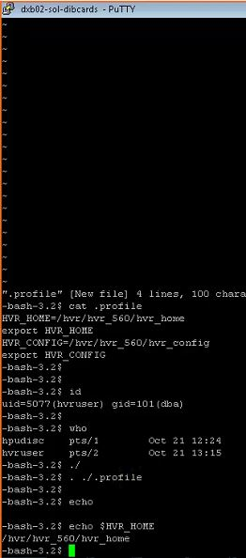

**STEP 4:**

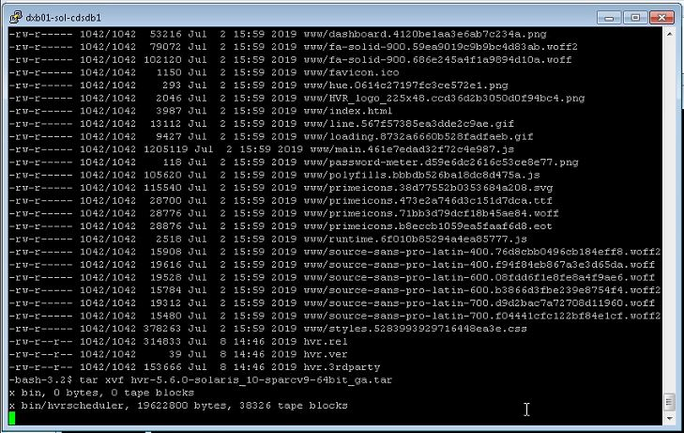

**STEP 5:**

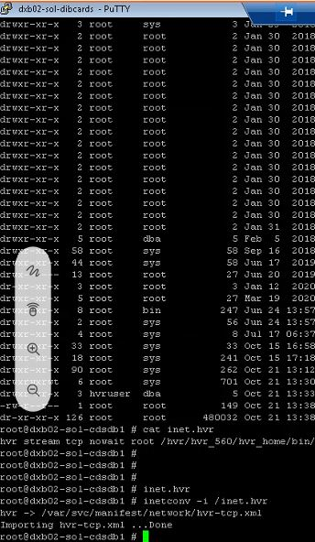

**STEP 5:**

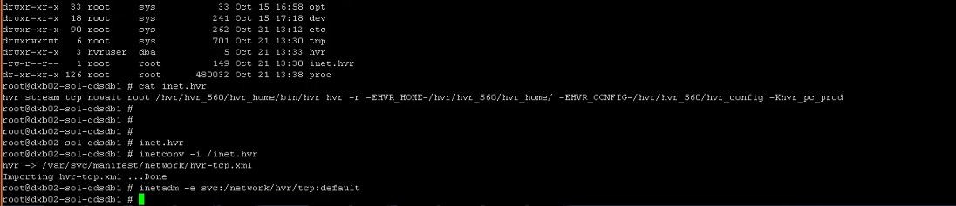

**STEP 6:**

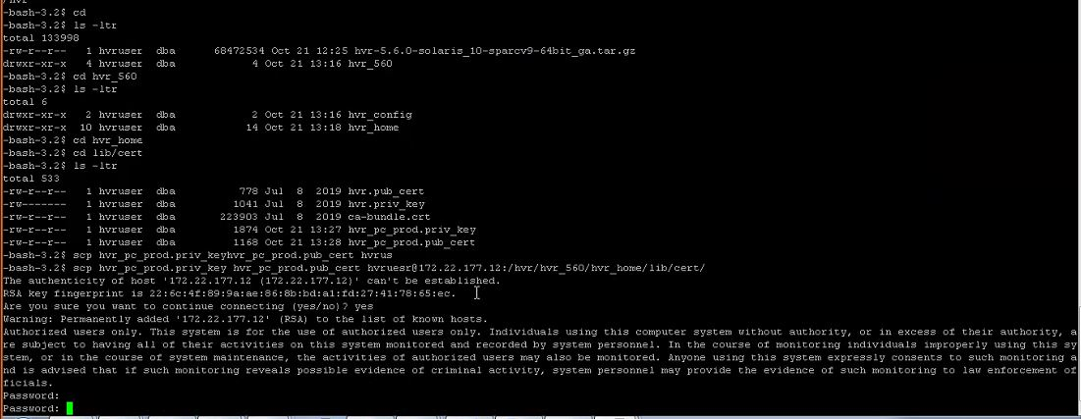

**STEP 7:**

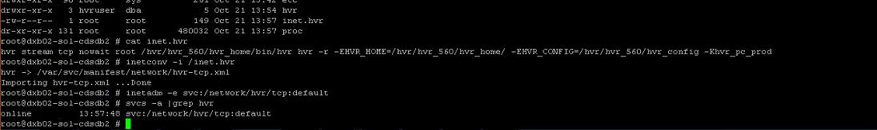

**STEP 8:**

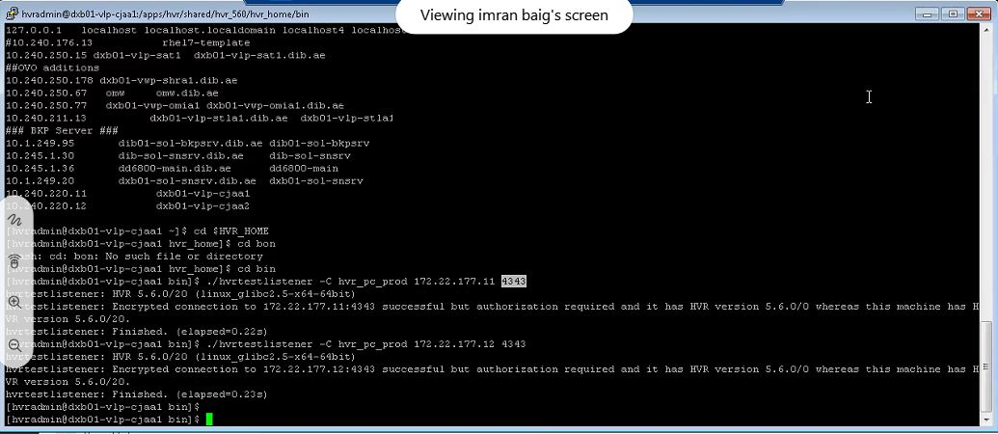

**STEP 9:**

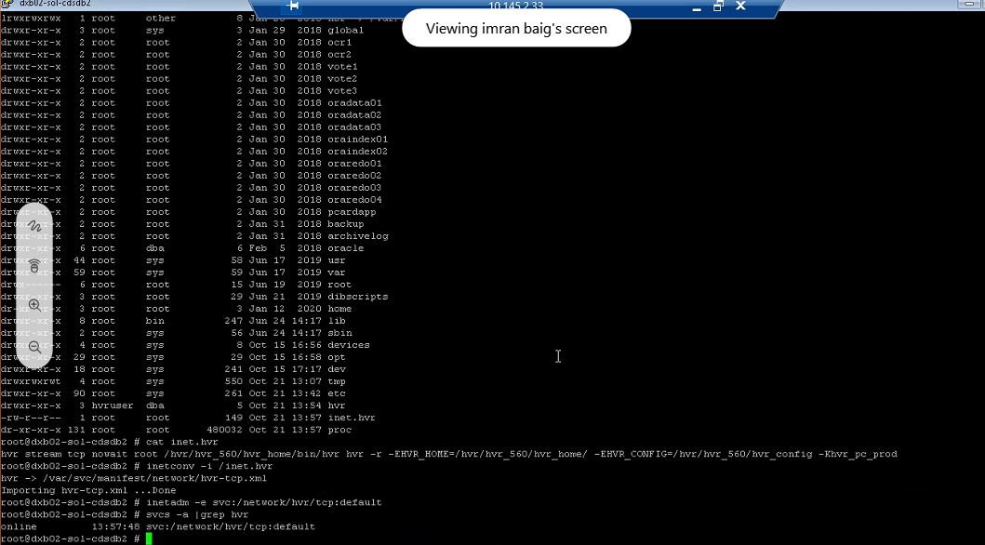

## **SOA**

**STEP 1:**

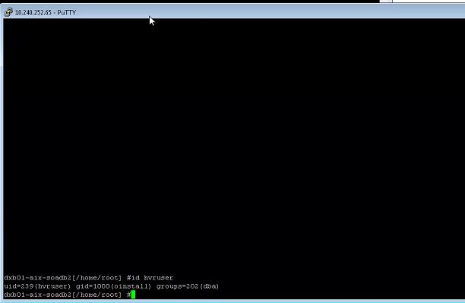

**STEP 2:**

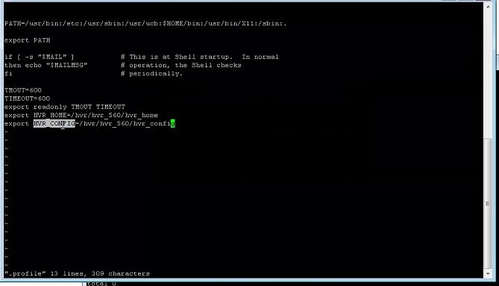

**STEP 3:**

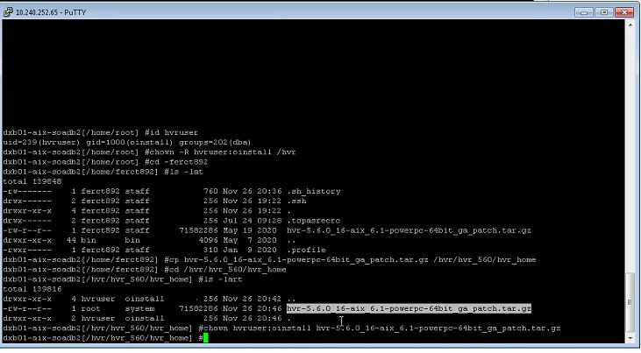

**STEP 4:**

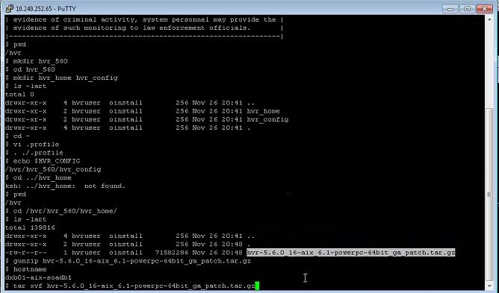

**STEP 5:**

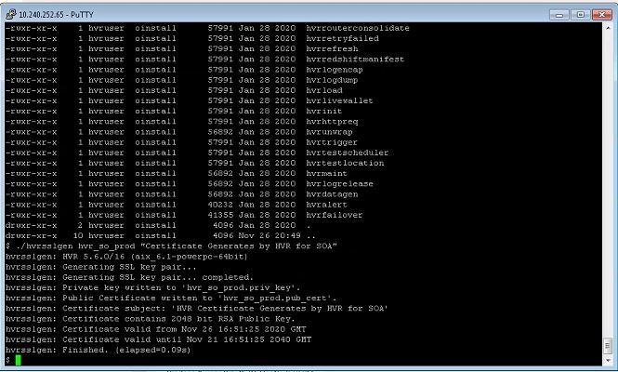

**STEP 6:**

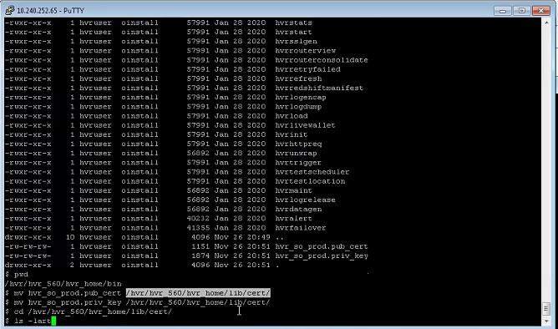

**STEP 7:**

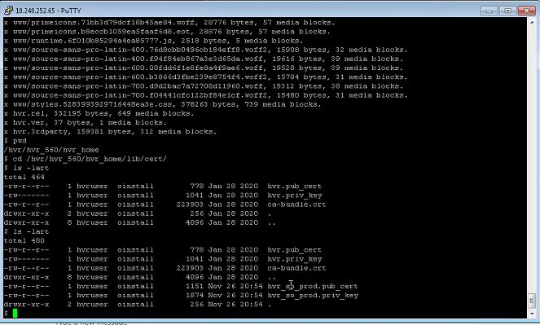

**STEP 8:**

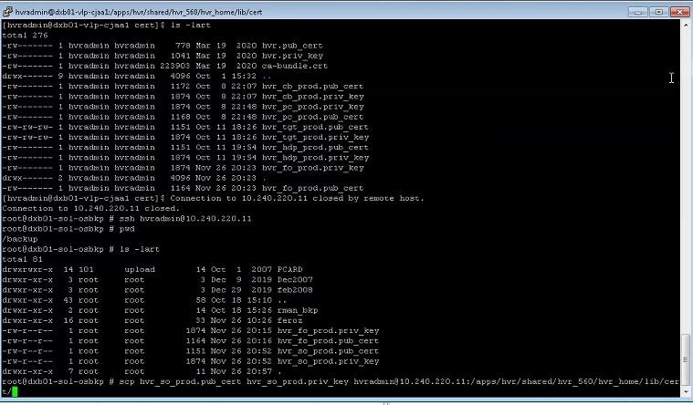

**STEP 9:**

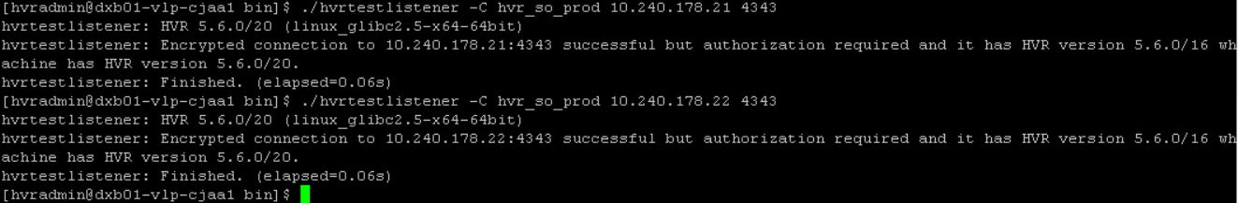

**STEP 10:**

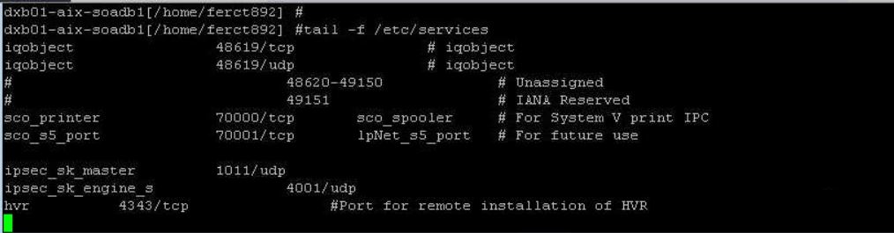

## **SOA DR**

**STEP 1:**

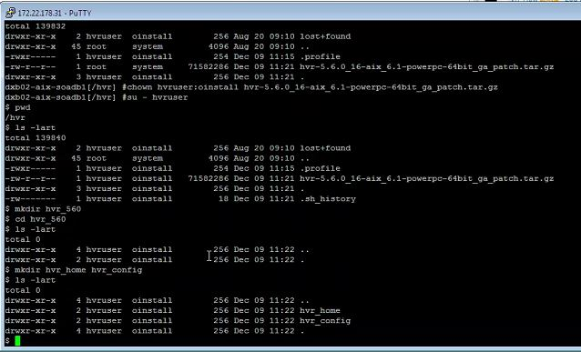



**STEP 2:**



**STEP 3:**



**STEP 4:**



**STEP 5:**

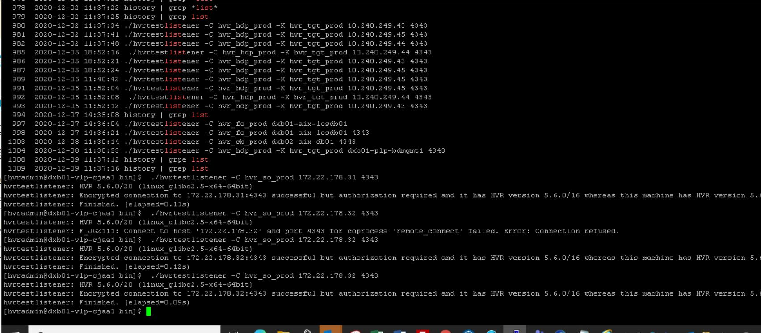

# **HVR AGENT INSTALLATION ON SOURCE SERVERS - WINDOWS**

## **INTERNET BANKING**

### INTERNET BANKING - NODE 1

**STEP 1:**

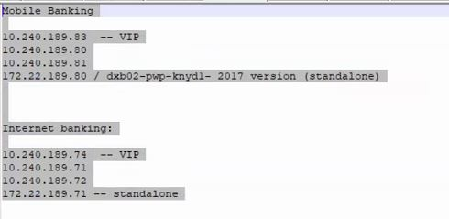

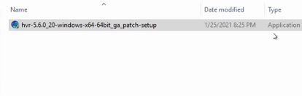

**STEP 2:**

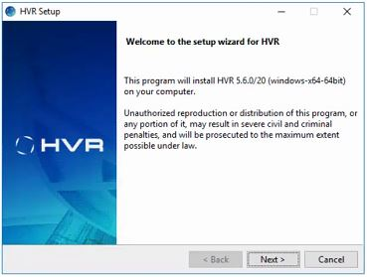

**STEP 3:**

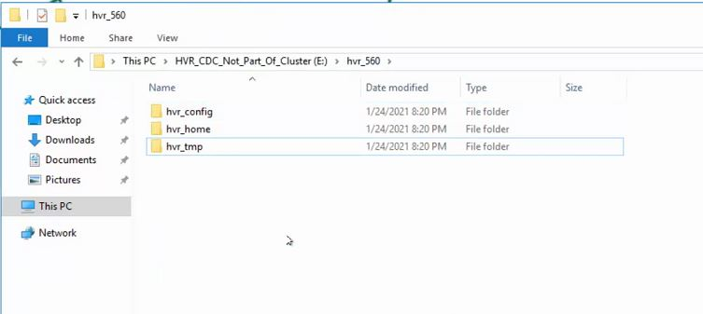

**STEP 4:**

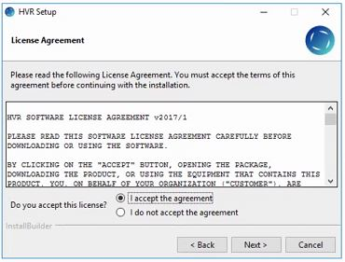

**STEP 5:**

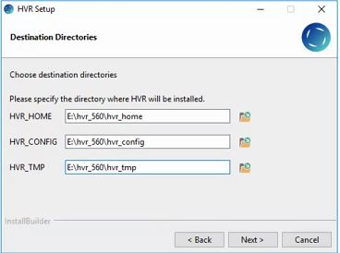

**STEP 6:**

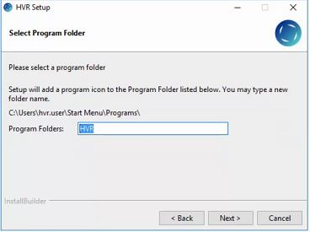

**STEP 7:**

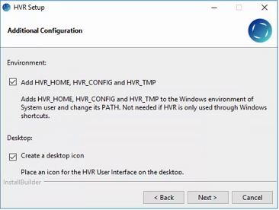

**STEP 8:**

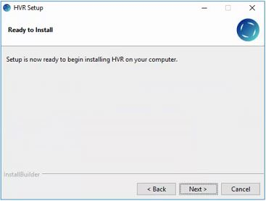

**STEP 9:**

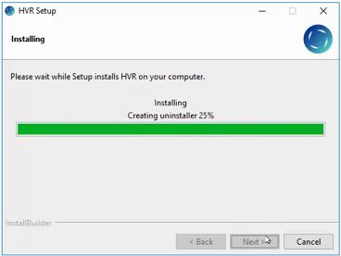

**STEP 10:**

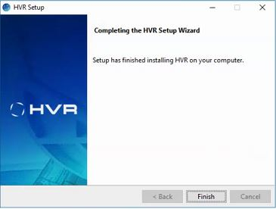

**STEP 11:**

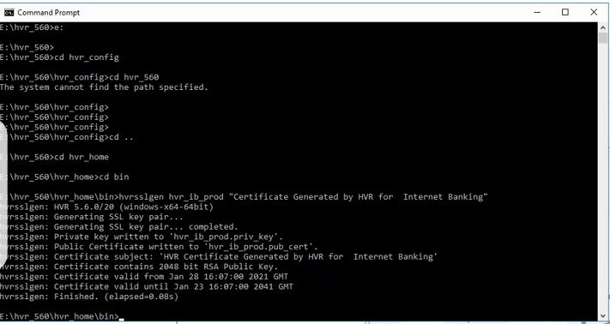

**STEP 12:**

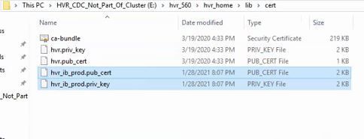

**STEP 13:**

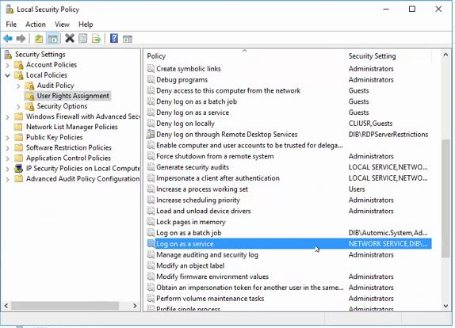

**STEP 14:**

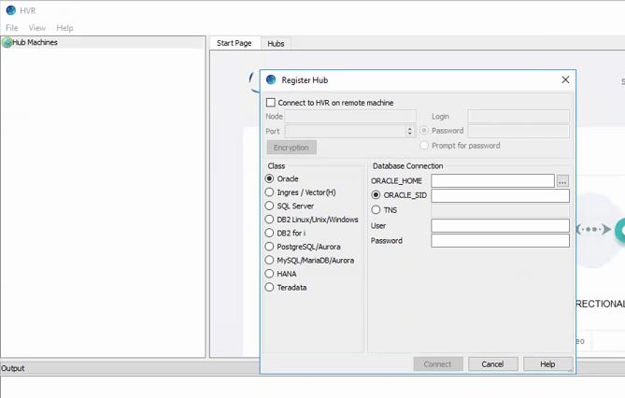

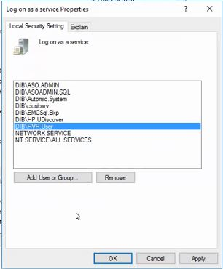

**STEP 15:**

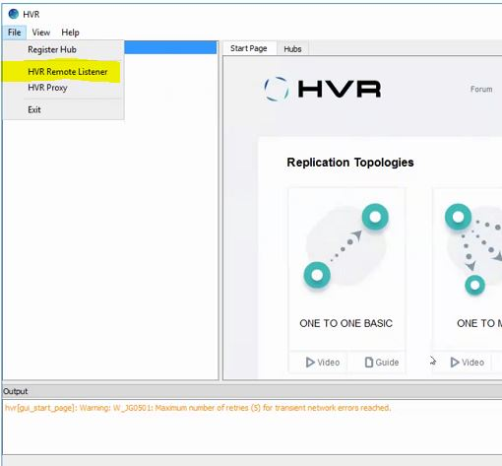

**STEP 16:**

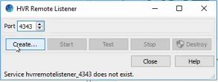

**STEP 17:**

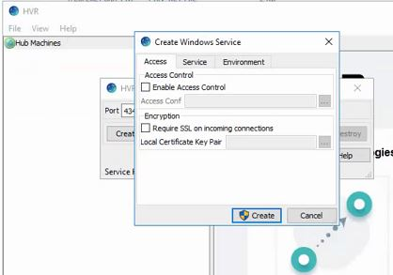

**STEP 18:**

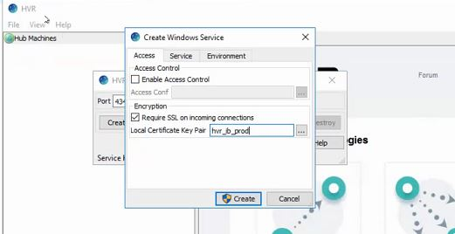

**STEP 19:**

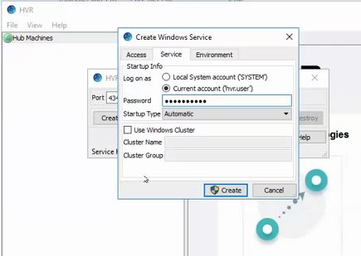

**STEP 20 :**

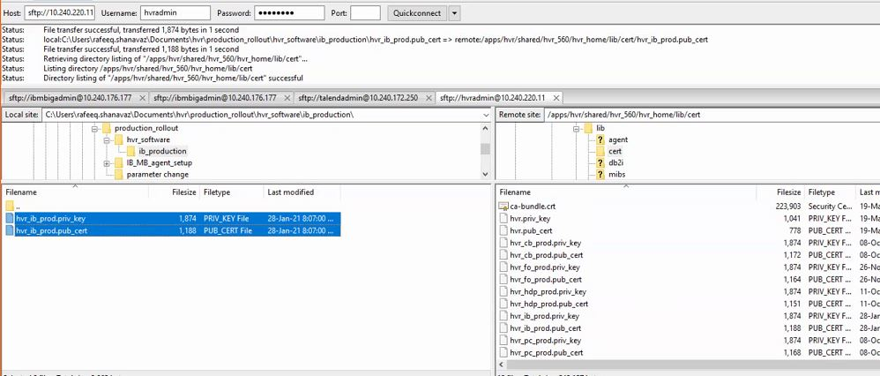

**STEP 21:**

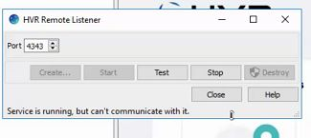

**STEP 22:**

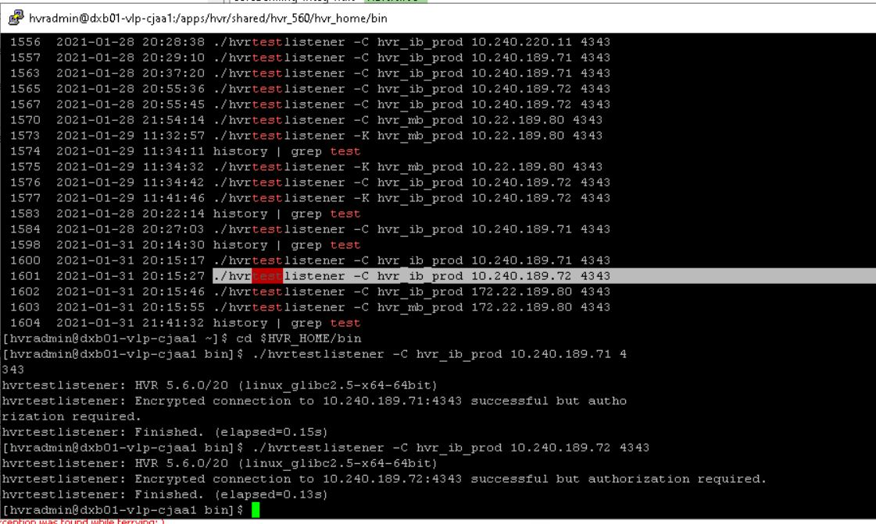

### INTERNET BANKING - NODE 2

**STEP 1:**





**STEP 2:**



**STEP 3:**



**STEP 4:**



**STEP 5:**

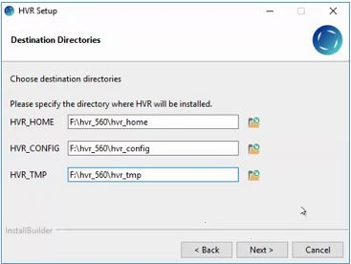

**STEP 6:**



**STEP 7:**



**STEP 8:**



**STEP 9:**



**STEP 10:**



**STEP 11:**



**STEP 12:**



**STEP 13:**



**STEP 14:**





**STEP 15:**



**STEP 16:**



**STEP 17:**



**STEP 18:**



**STEP 19:**



**STEP 20 :**



**STEP 21:**



**STEP 22:**



### INTERNET BANKING – DR

**STEP 1:**





**STEP 2:**



**STEP 3:**



**STEP 4:**



**STEP 5:**

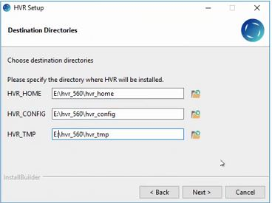

**STEP 6:**



**STEP 7:**



**STEP 8:**



**STEP 9:**



**STEP 10:**



**STEP 11:**



**STEP 12:**



**STEP 13:**



**STEP 14:**





**STEP 15:**



**STEP 16:**



**STEP 17:**



**STEP 18:**



**STEP 19:**



**STEP 20 :**



**STEP 21:**



**STEP 22:**



**TEST**



## **MOBILE BANKING**

### MOBILE BANKING – NODE 1

**STEP 1:**

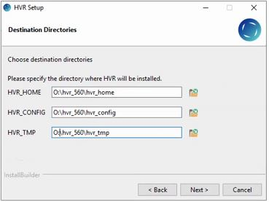

**STEP 2:**

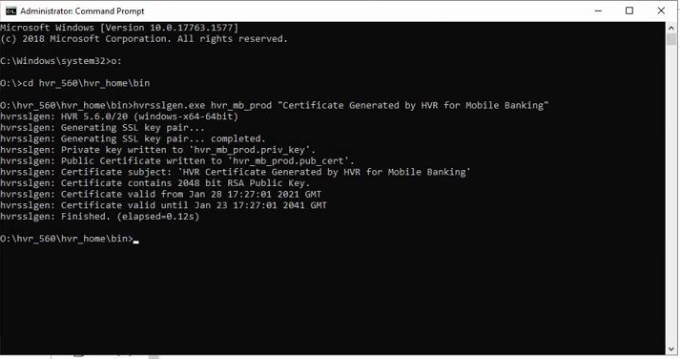

**STEP 3:**

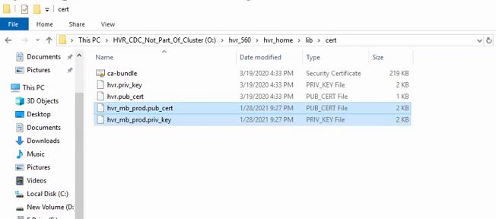

**STEP 4:**

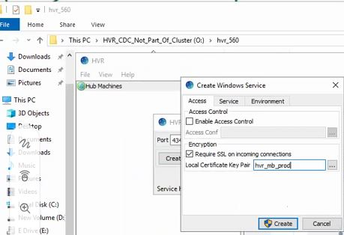

**STEP 5:**

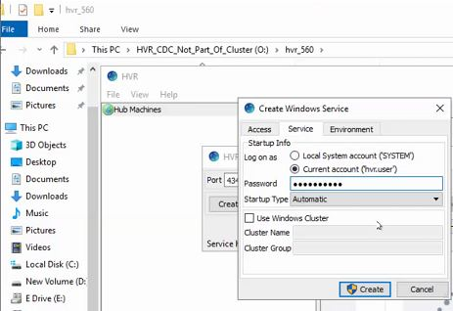

**STEP 6:**



### MOBILE BANKING – NODE 2

**STEP 1:**



**STEP 2:**



**STEP 3:**



### MOBILE BANKING – DR

**STEP 1:**

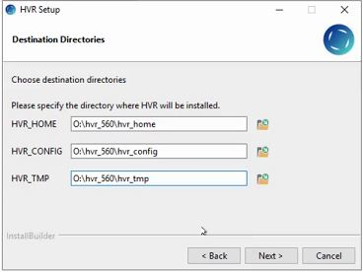

**STEP 2:**

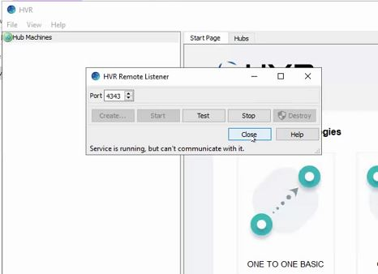

**STEP 3:**

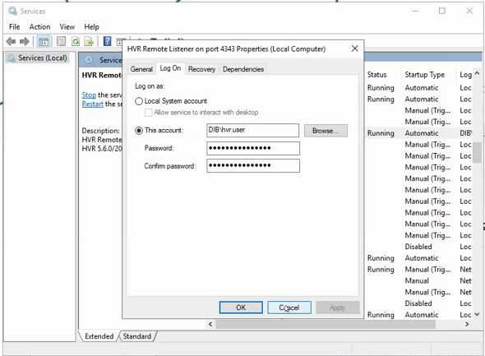

**STEP 4:**



# **TARGET SERVERS – LINUX**

## **BIGDATA**

### BIGDATA SERVER 1

**STEP 1:**

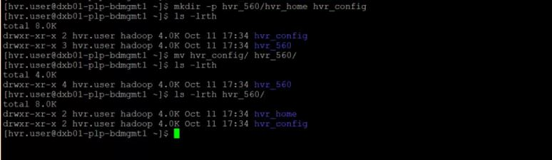

**STEP 2:**

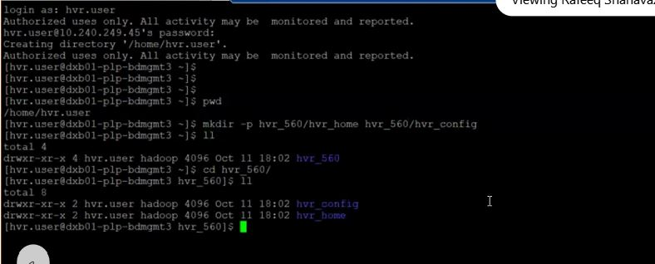

**STEP 3:**

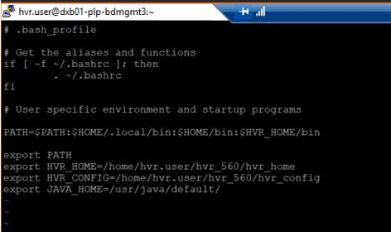

**STEP 4:**

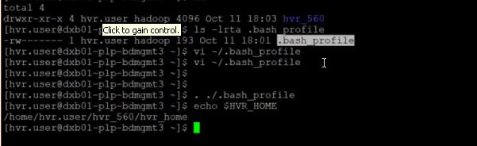

**STEP 5:**

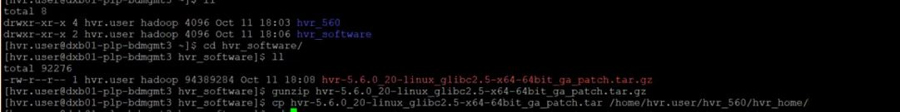

**STEP 6:**

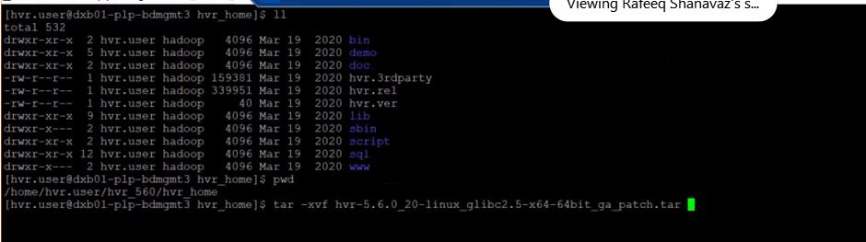

**STEP 7:**

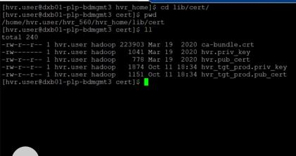

**STEP 8:**

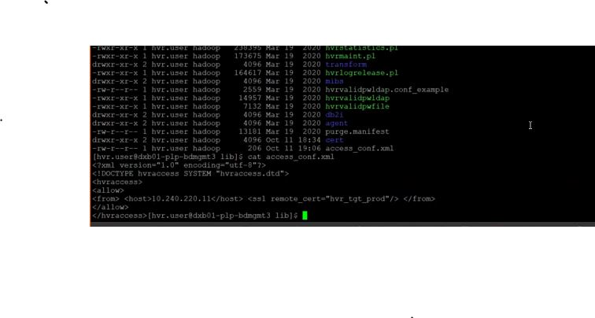

**STEP 9:**

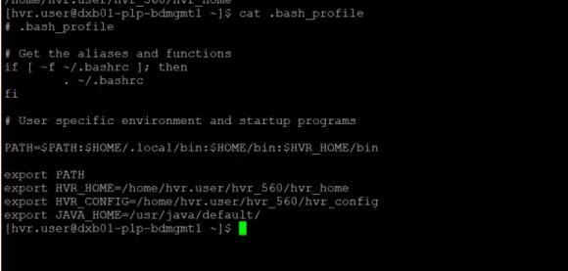

**STEP 10:**

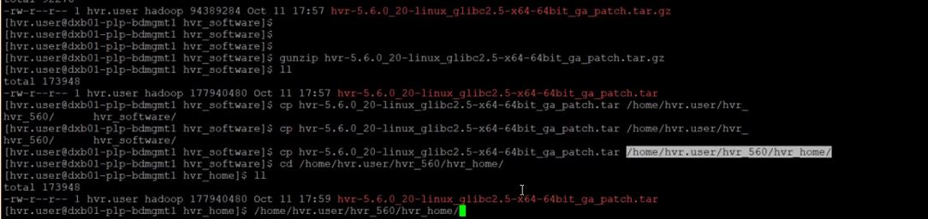

**STEP 11:**

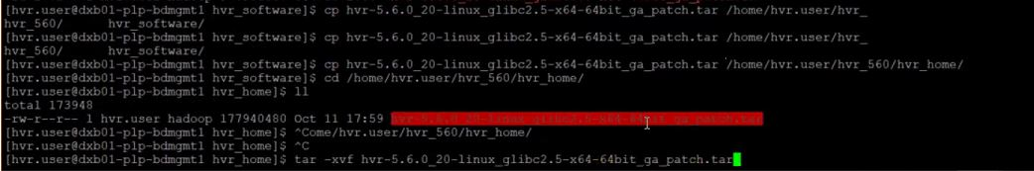

**STEP 12:**

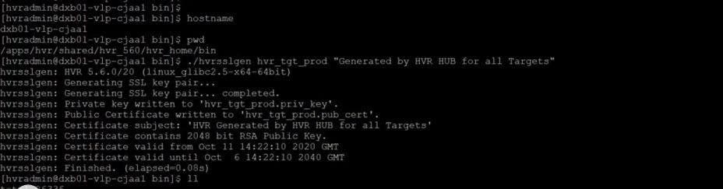

**STEP 13:**

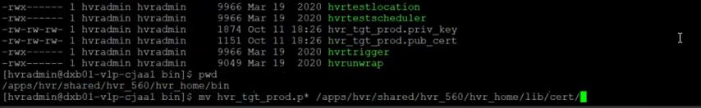

**STEP 14:**

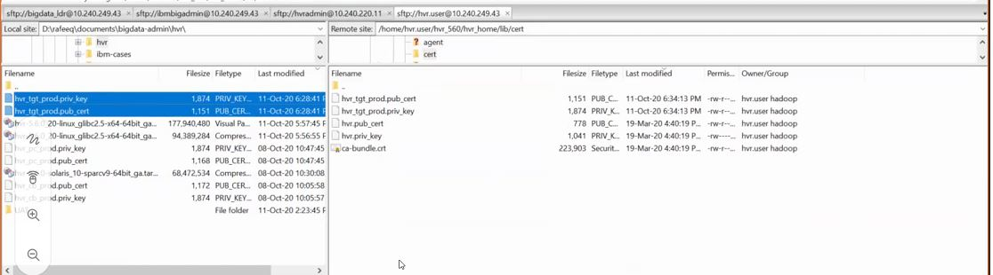

**STEP 15:**

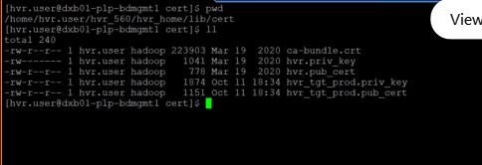

**STEP 16:**

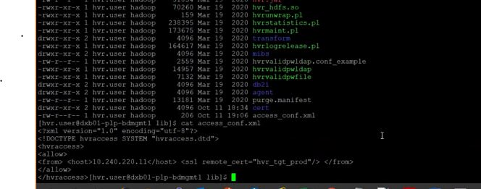

**STEP 17:**

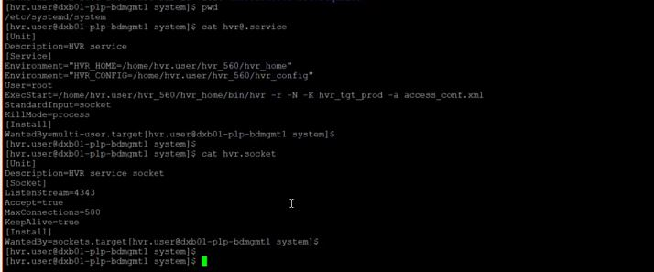

**STEP 18:**

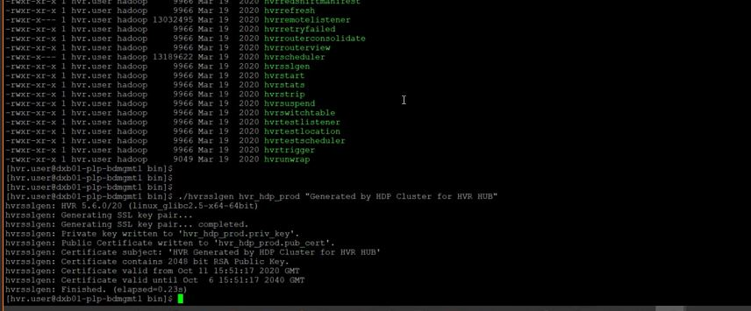

**STEP 19:**

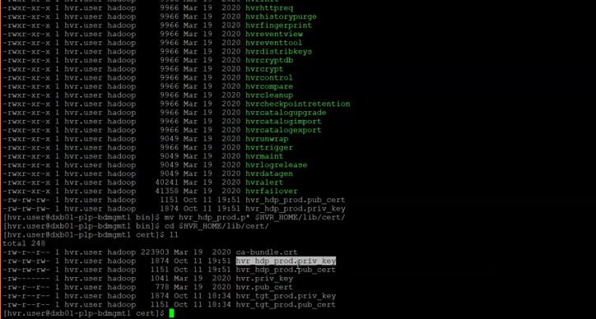

**STEP 20 :**

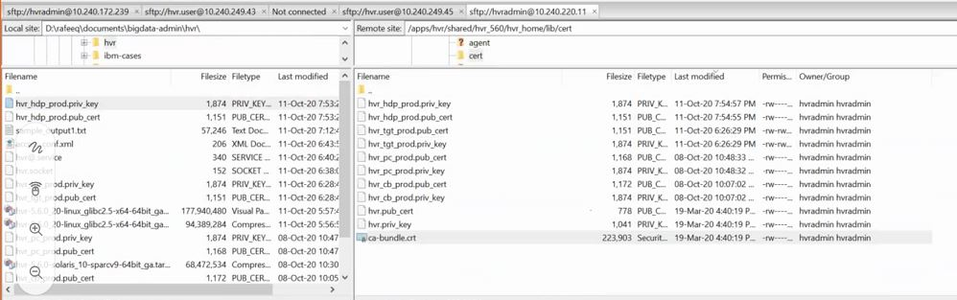

**STEP 21:**

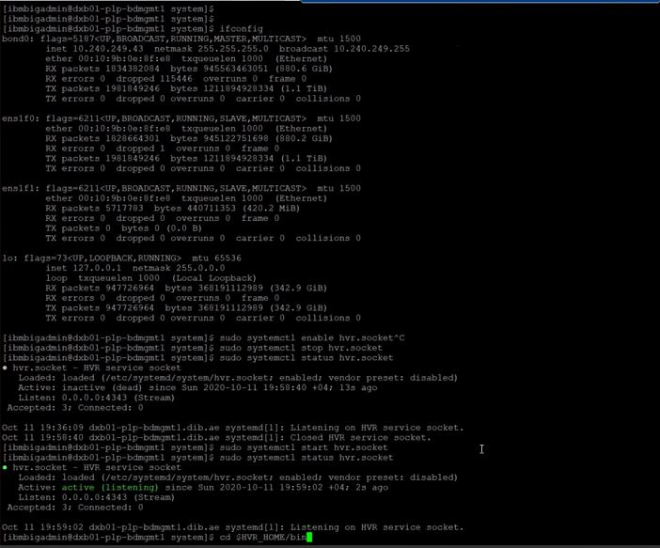

**STEP 22**



### BIGDATA SERVER 2

**STEP 1:**

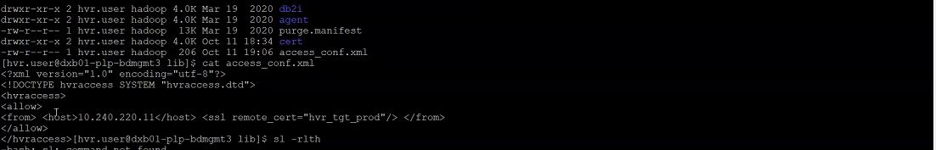

**STEP 2:**

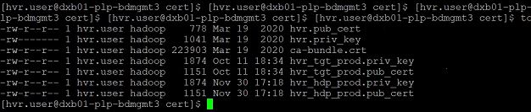

**STEP 3:**



**STEP 4:**



**STEP 5:**

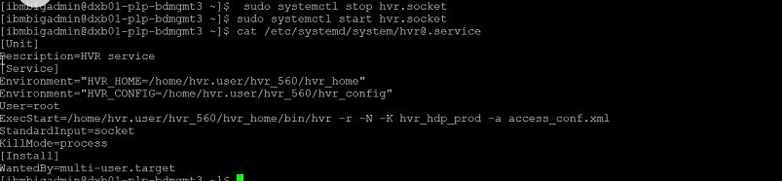

### BIGDATA SERVER 3

**STEP 1:**

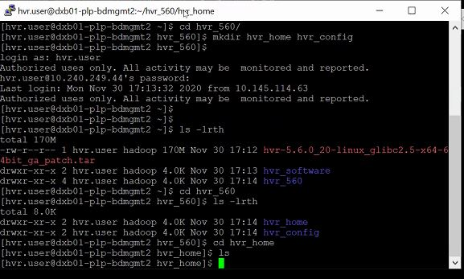

**STEP 2:**

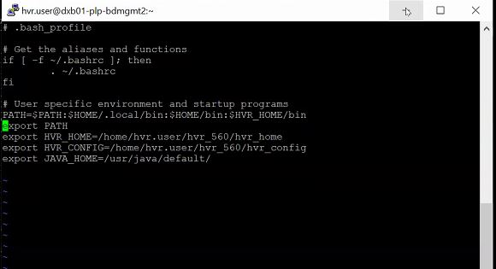

**STEP 3:**

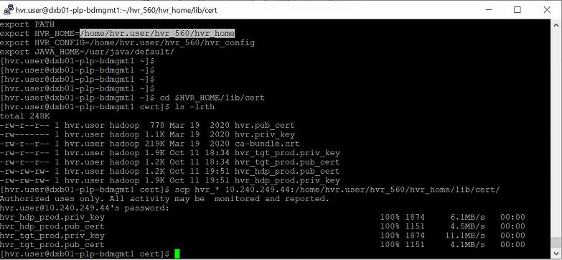

**STEP 4:**

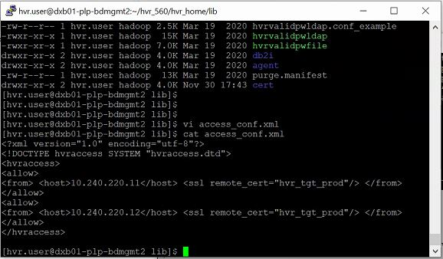

**STEP 5:**

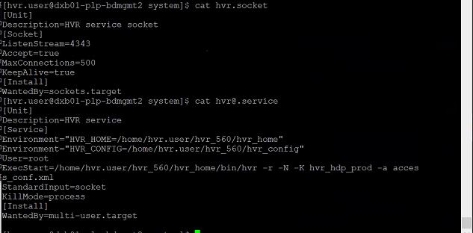

**STEP 6:**

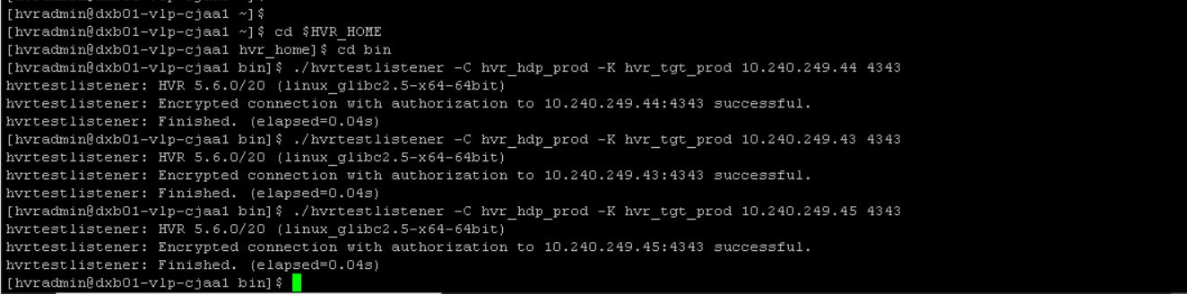

# **GUI CONFIGURATION**

## CORE BANKING

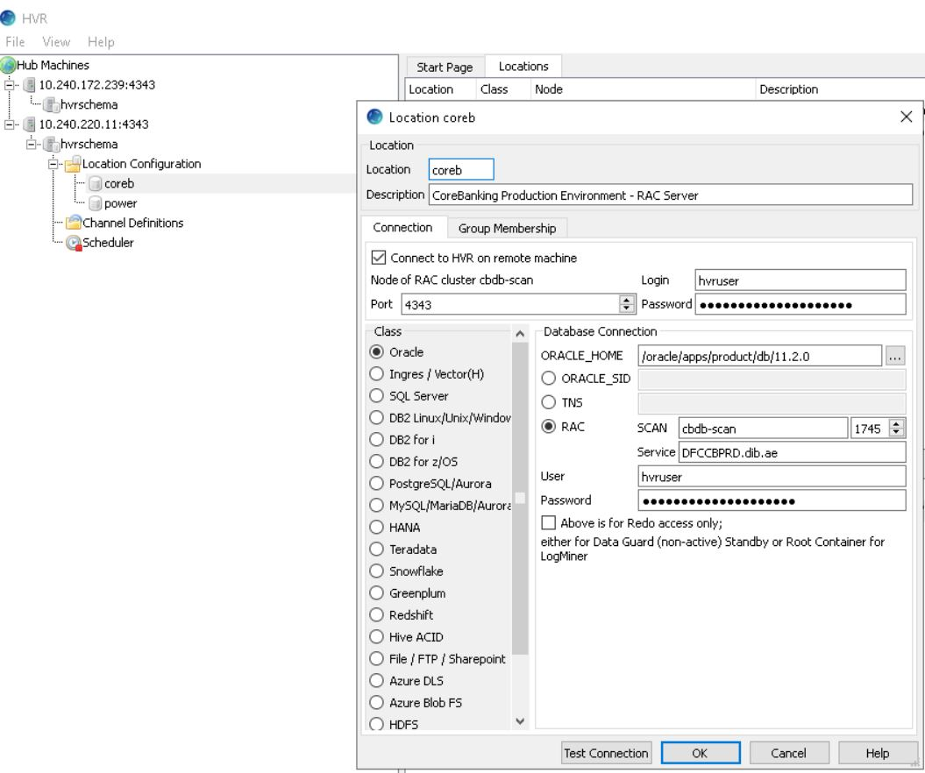

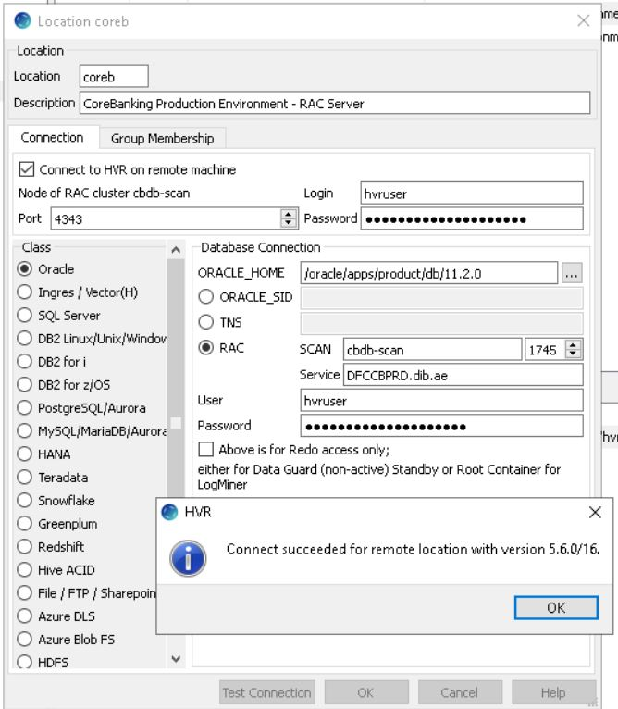

## FINNONE

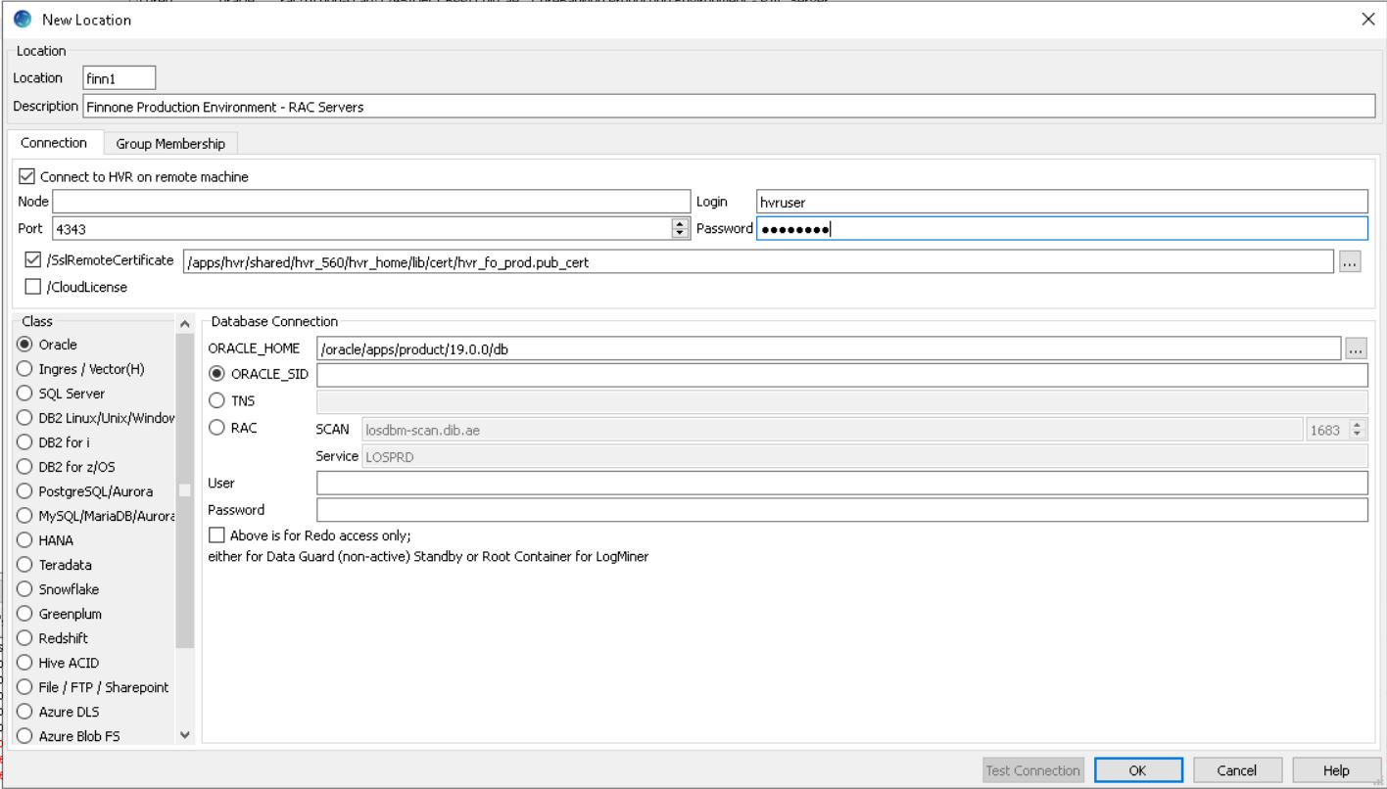

## HDFS

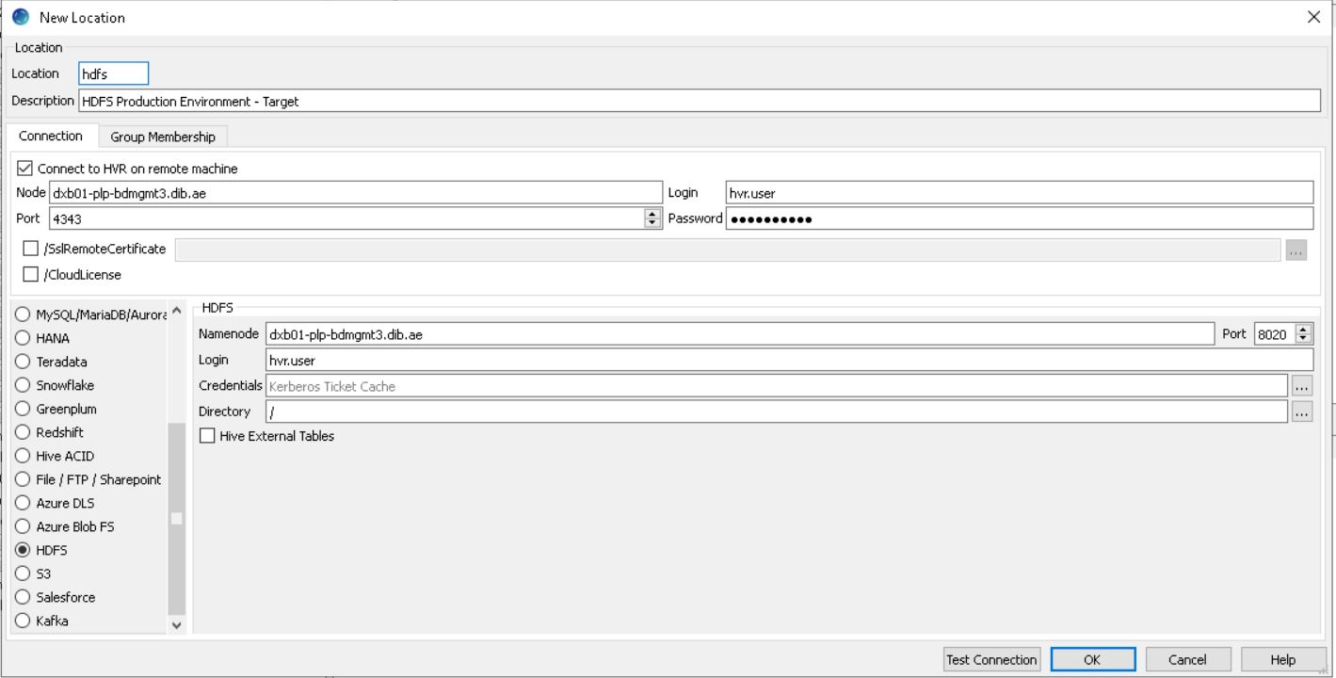

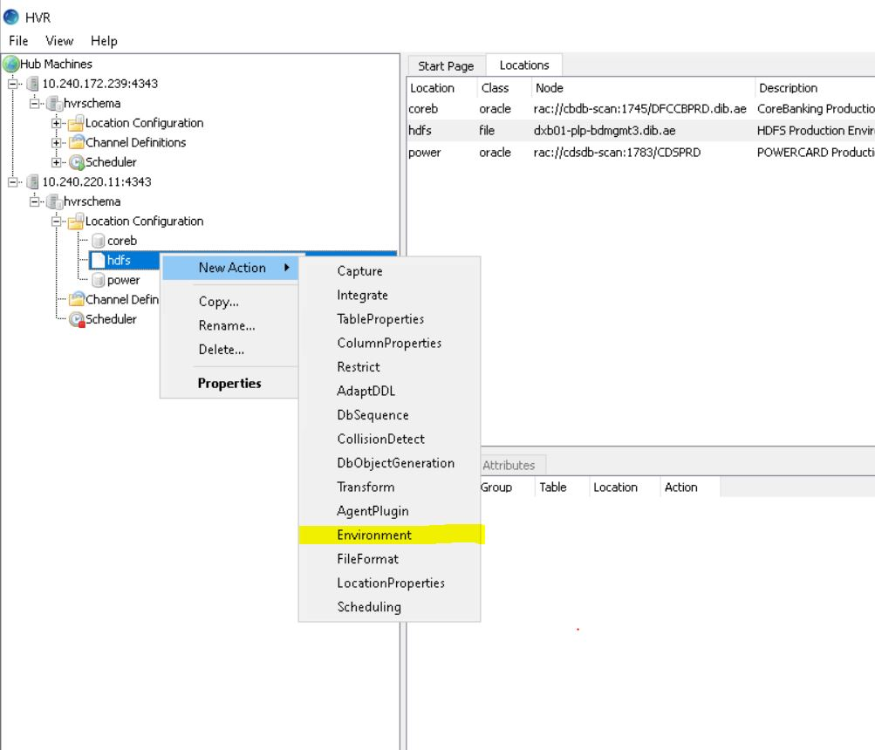

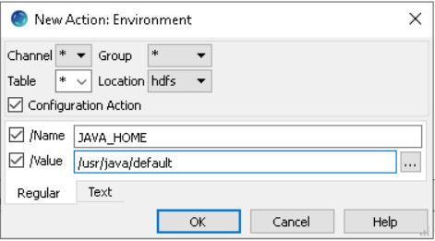

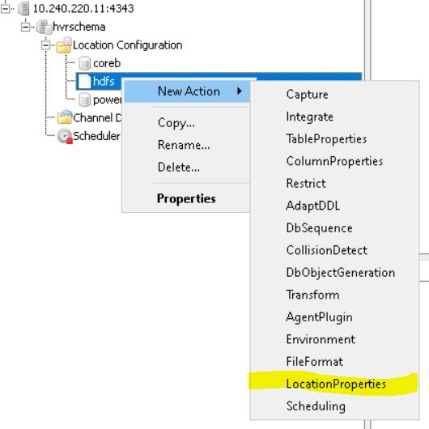

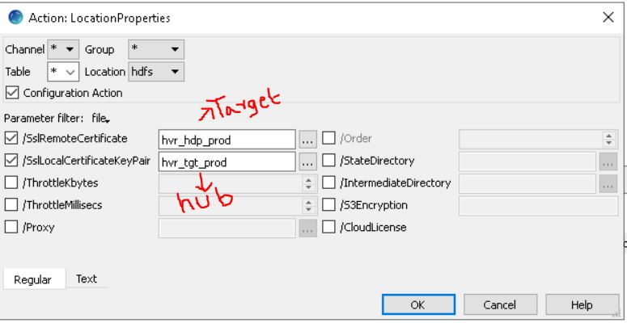

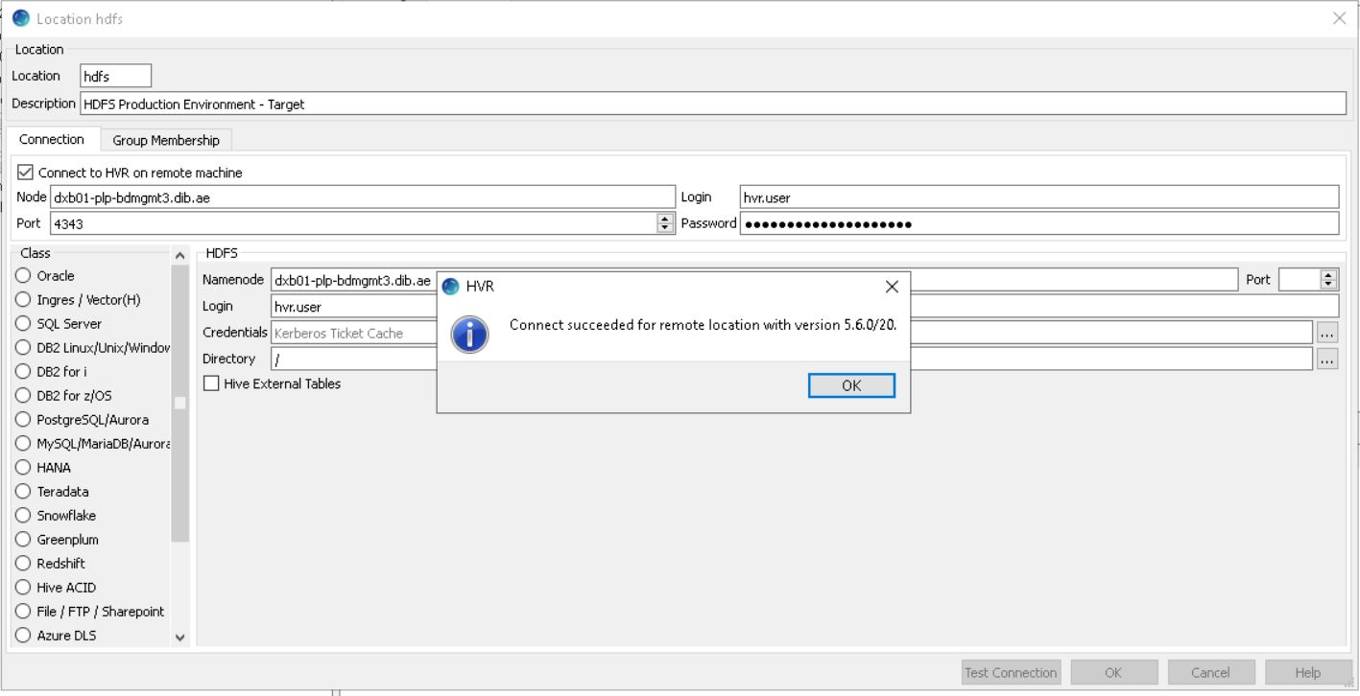

## KAFKA

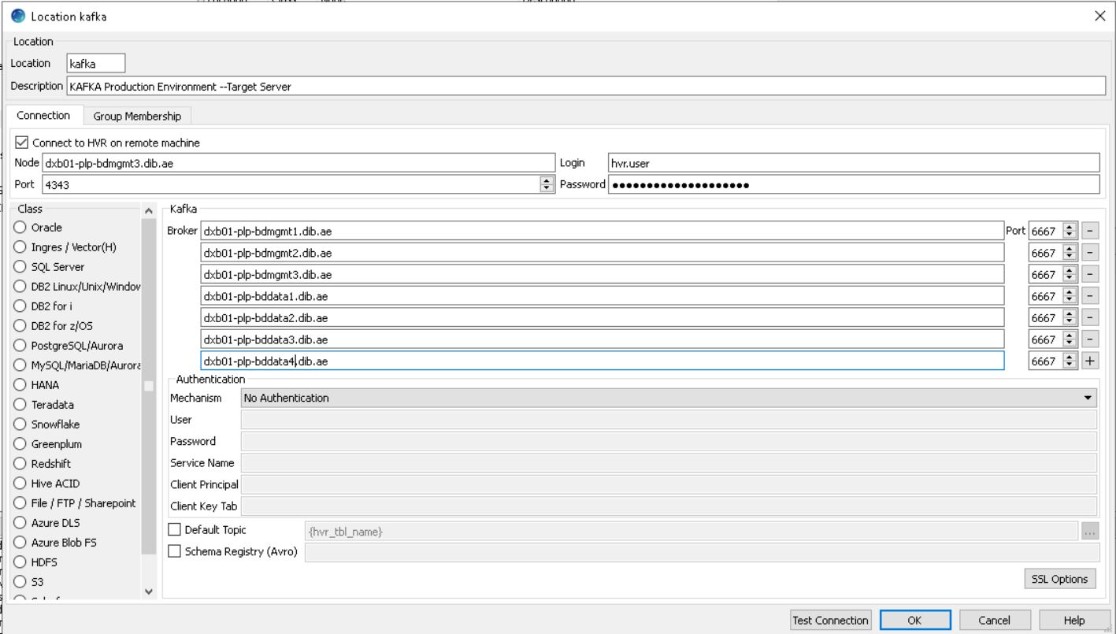

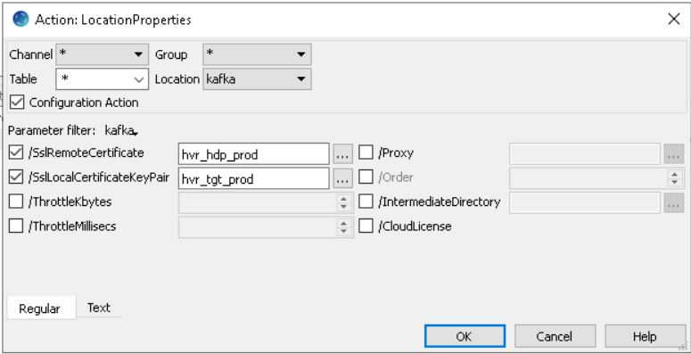

## POWERCARD

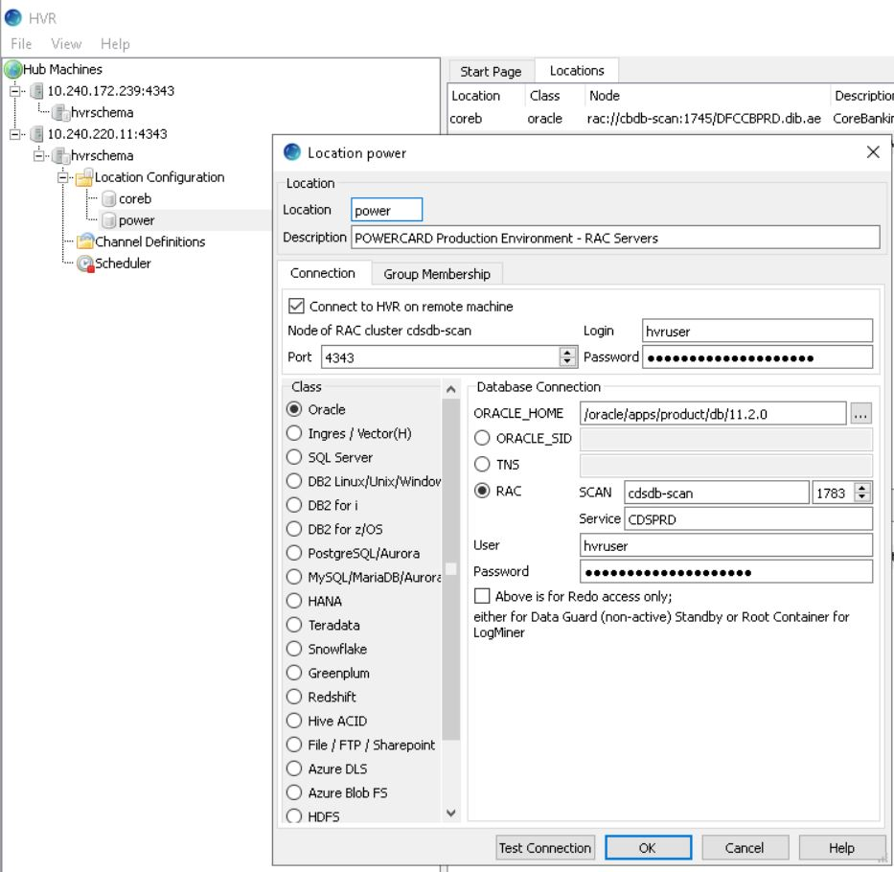

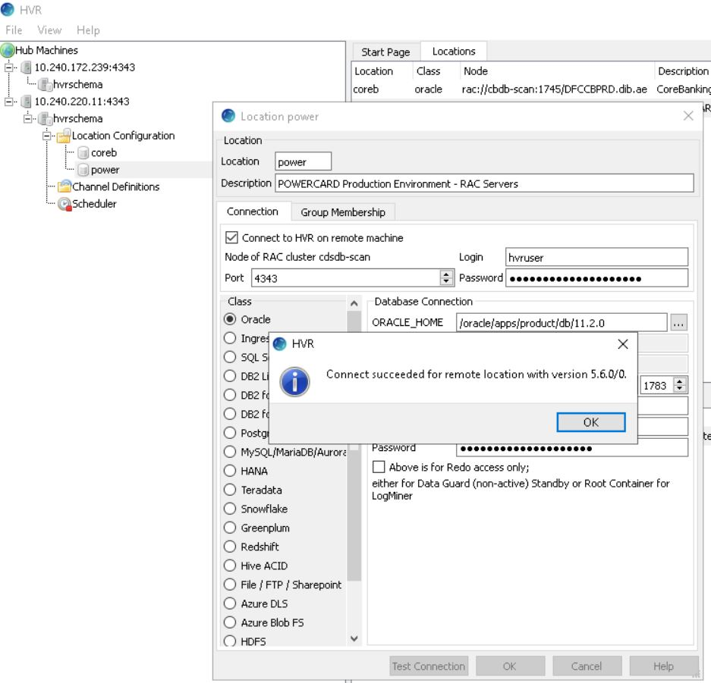

## SOA

